

**GIFT ONLINE**

**eREPORT**

**DECLARATION**

This project is our original work and has not been presented in previous Event.

THE PROJECT TEAM INCLUDE

ELISHA MUKHULE MWAKHA

Table of Contents

CHAPTER 1: SYNOPSIS 7

BACKGROUND INFORMATION 7

Statement of the problem/ORIGINALITY 8

Objectives 8

LIMITATIONS 9

CHAPTER 2: ANALYSIS 10

HARDWARE AND SOFTWARE USED 10

CHAPTER 3: DESIGNS 11

WEBSITE DESIGN 11

Data flow Diagram (DFD)DESIGN 11

Flowchart DESIGN 12

Process DESIGN 13

STRUCTURE *DESIGN* 14

Homepage design 14

About Us 16

Birthday Gifts for Her 18

Contact page design 21

About us page design 24

Mobile css structure 25

SCREEN SHOTS 28

Home page 28

Footer 29

Site Map page 30

About Us 30

Download page 32

Contact Us page 32

Birthday Gifts 34

Birthday Gifts for her page 35

Birthday Gifts for him page 37

Cakes For Birthday 39

Top Brands 41

Chanel 42

Gucci Page 44

Louis Vuitton Page 48

Gifts By Category 49

Personalized Gifts page 50

Personalized Mugs Page 50

Personalized Cushions and Pillows Page 51

Personalized Clocks Page 52

Flowers Page 55

Pink Roses Page 58

Red Roses Page 58

Cakes Page 59

Jewelry Page 62

Download page 65

Source code with comments 66

The html code use in the home page 66

Html code used in the Site Map page, contact page, about us page and download page 77

Contact page code 77

About us code 81

Download page code 87

USER GUIDE 92

DEVELOPERS GUIDE 97

CHAPTER 4: CONCLUSION AND RECOMMENDATION 122

**ABSTRACT**

Previous studies show a positive relationship between the number of Internet users and online shoppers. The use of internet in Kenya has grown tremendously over the years. The introduction of submarine fiber optic cables in 2009 has improved the speeds of internet resulting to lower telecommunications costs and new opportunities across many sectors. Online shopping in Kenya has has taken off strongly with the steady increase of internet users over the years. Studies done revealed that among those who shopped online in the Kenyan, college students aged 18 to 22 were the biggest market and a prime source of future growth in online sales. As a result of this we came up with an idea of also digitalizing the gift shopping industry by creating Gift Online where one can order a gift from anywhere within Kenya and have it delivered to him or her or his loved one as fast possible.

**ACKNOWLEDGEMENT**

The success and final outcome of this project required a lot of guidance and assistance from many people and we are extremely fortunate to have gotten their help towards the completion of this project.

I owe my profound gratitude to our Lecturer Mr. Nyanjui who took keen interest in my project work and guided as till the completion by providing all the information needed for a good system.

I am thankful and fortunate enough to get constant encouragement support and guidance from all the teaching staff of Edu link International College and the students at large.

# CHAPTER 1: SYNOPSIS

### BACKGROUND INFORMATION

Truly, the Internet today has quickly evolved to be one of the most powerful communication tools worldwide and has also penetrated into our social and economic life. Increasingly, businesses are recognizing the potential of the Internet and it has been noted that the Internet is becoming a hotbed for advertising and commercial activity (Verity, 1994). The Internet was first introduced in Kenya in 1993 on a non-commercial basis. But as years went by the internet has turned out to be close to one of the basic need. With the current ongoing pandemic, it came up with more stringent measures and as a result pushed us to find a better solution to serve all our customers better as well as follow the set regulations. With the Gift online we can now kill two stones with one bird, rather~ two birds with one stone.

### Statement of the problem/ORIGINALITY

The results brought up by the need to reach more customers in time and ensuring their orders are all packed, prepared and dispatched in time. Nevertheless follow the current pandemic regulations such as avoiding crowded places and one on one contact.

### Objectives

1. To offer quality and authentic gifts in Africa.
2. To come up with a well responsive and friendly website to help different type of people reach us.

### LIMITATIONS

#### Merits

1. The website is mobile friendly, hence it can be used in most of the mobile phones be it with large screens or small screens.
2. One can place his order from anywhere, it does not matter where you are.
3. The website user friendly, anyone can use it.

#### Demerits

1. Since it is a website application, the website can be attacked by malicious hackers or virus.

# CHAPTER 2: ANALYSIS

The objective of the study was to not only come up with a good user friendly gift online website, but also determine the level of awareness and use of online shopping among students, to find out the reasons for adoption or non-adoption of online shopping as well as to establish the profile of users of online shopping. The study was carried out among the University of Nairobi School of business evening students by Jane Wambui Jenga. The data was collected by use of questionnaires. A total of 248 questionnaires were distributed by out of which 204 were returned having being correctly filled. The rate of responses was therefore 82% with the lion share being students who were aware of the online shopping. This then creates a pool of prospects out there ready to be utilized with our premium gifts.

## HARDWARE AND SOFTWARE USED

1. Full Computer system.
2. Windows 10.
3. Dreamweaver CS6.
4. Notepad ++ v7.3.3
5. Microsoft office word 2013.

Note: All softwares above were of 64 bit type

# CHAPTER 3: DESIGNS

## WEBSITE DESIGN

### Data flow Diagram (DFD)DESIGN

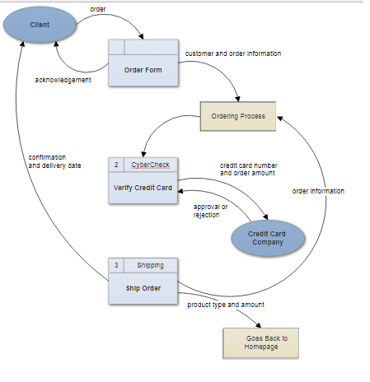

### Flowchart DESIGN

Customer must enter new payment method

Credit card valid?

Customer sent receipt via e-mail

Validate through Verified by Visa

Transaction started in order system

Order placed with credit card selected as payment method

NO

YES NO

Funds Available?

Customer information database

Transaction completed in order system

Transaction entered in ledger

### Process DESIGN

3.0 Procurem-ent

2.0

Product-ion

Employee

Inventory

Time Worked

Pay

Order Decisions

Payment

Purchase Order

Received Goods

Vendor

Production Schedule

Sales Forecast

Product Ordered

1.0

Sale

Products Served

Payment

Customer Order

Customer

4.0 Payroll

## STRUCTURE *DESIGN*

### Homepage design

*Background image

BIRTHDAY GIFTS

Birthday Gifts for Her

Birthday Gifts for Him

Cakes for Birthday

TOP BRANDS

Chanel

Gucci

Louis Vuitton

GIFT BY CATEGORY

Personalized Gifts

Flowers

cakes

Table fans

Contact Us

About us

Downloads

Add to cart

Home

HEAD

BODY

Text

Text

*logo

Image

Image

Image

Company’s Team

*Social Media Icon

*Social Media Icon

*Social Media Icon

Text…

Text…

*Site Map Link

*Email Link

Text…

FOOTER

Image

Image

Image

### About Us

About US

catalogue

Add to cart

Home

Contact Us

Text….

BODY

Text…

Text…

*Background Image

*Logo

HEAD

Text….

Text….

FOOTER

Text…

Text…

Text…

*Email Link

*Social Media Icon

*Social Media Icon

*Social Media Icon

FOOTER

### Birthday Gifts for Her

About US

catalogue

Add to cart

Home

Contact Us

Text….

BODY

Text…

Text…

*Background Image

*Logo

HEAD

Text….

Image

Image

Image

Image

Image

Text….

Text….

Image

Image

Image

Image

FOOTER

Text…

Text…

Text…

*Email Link

*Social Media Icon

*Social Media Icon

*Social Media Icon

### Contact page design

About

Gallery

Downloads

Shop

Home

BODY

Text…

Text…

*Logo

HEAD

Submit

Email link

Form

Text…

Form

Text…

Geolocation

Text….

FOOTER

Text…

Text…

Text…

*Email Link

*Social Media Icon

*Social Media Icon

*Social Media Icon

### About us page design

HEAD

Downloads

Gallery

Contact

Shop

Home

Text…

Text…

Text…

Text….

BODY

Text…

Text…

*Background image

*Logo

Text…

*Email Link

FOOTER

### Mobile css structure

*Social Media Icon

*Social Media Icon

*Social Media Icon

Text…

Text…

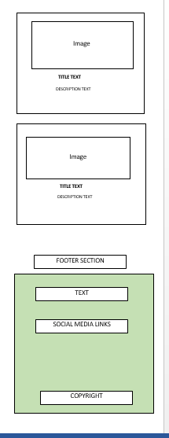

## SCREEN SHOTS

### Home page

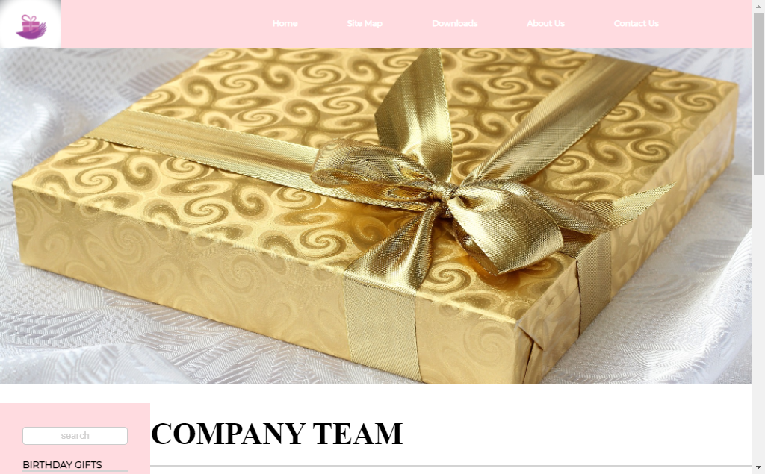

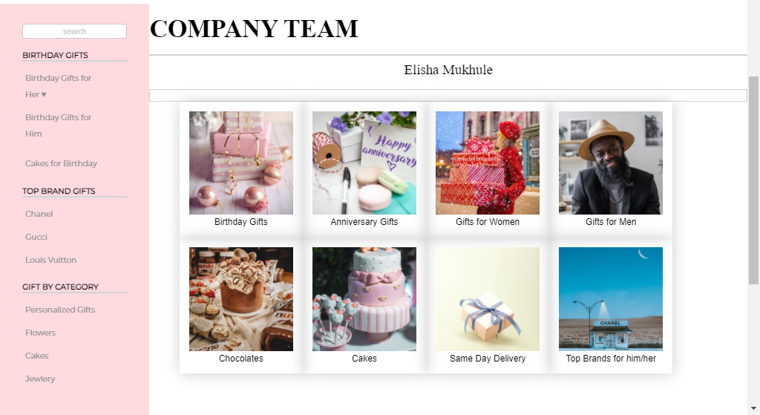

### Footer

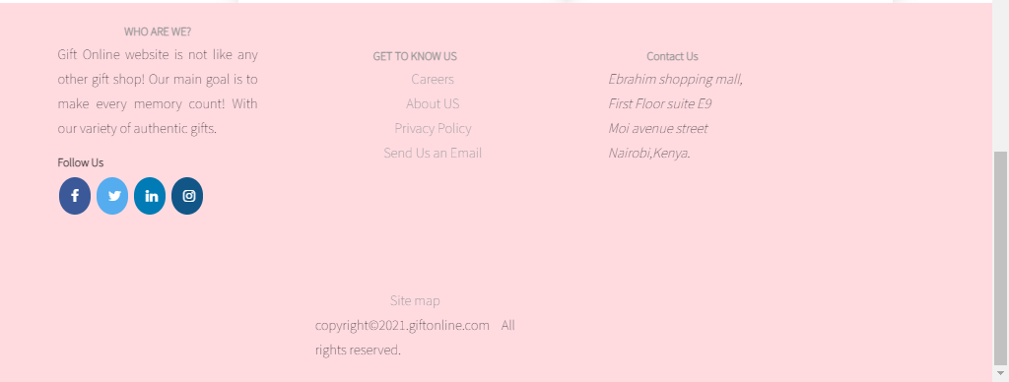

### Site Map page

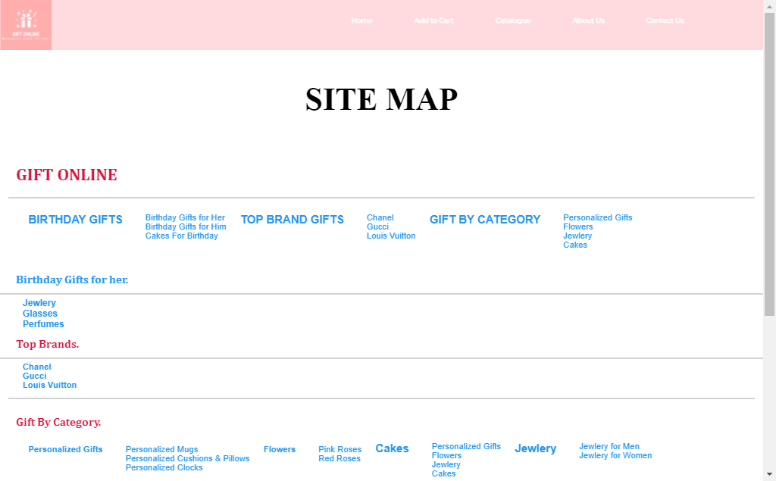

### About Us

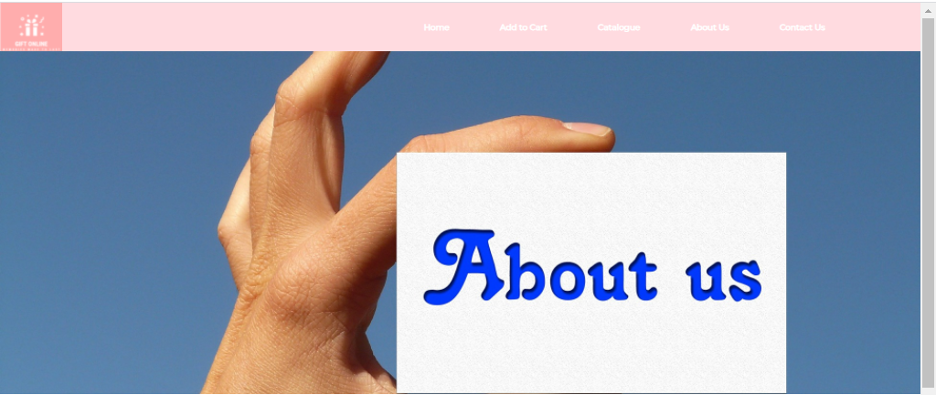

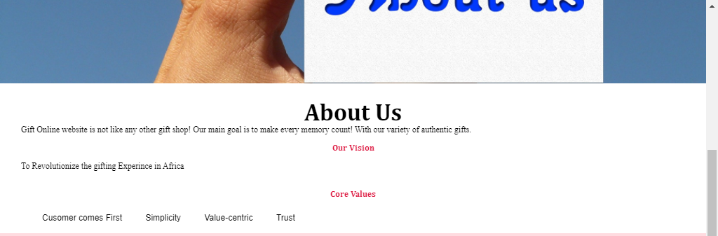

### Download page

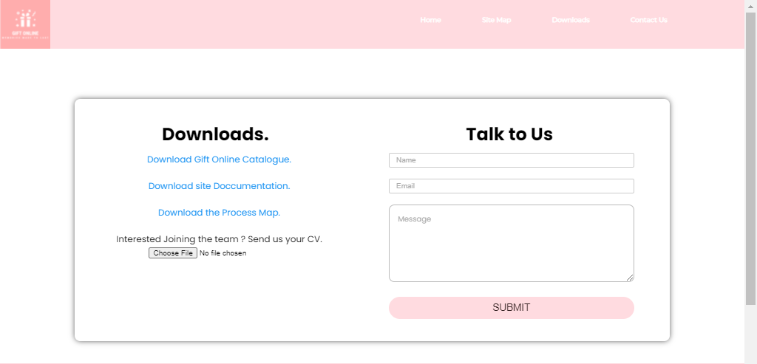

### Contact Us page

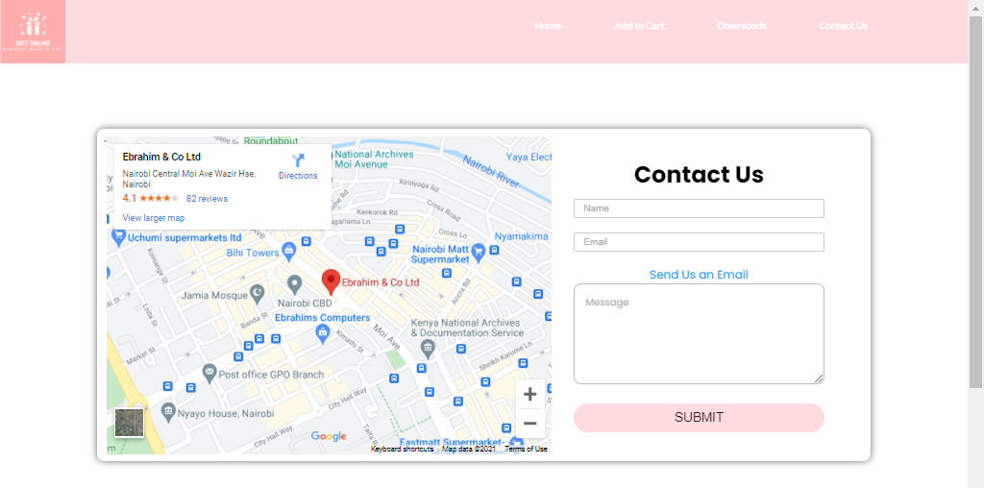

### Birthday Gifts

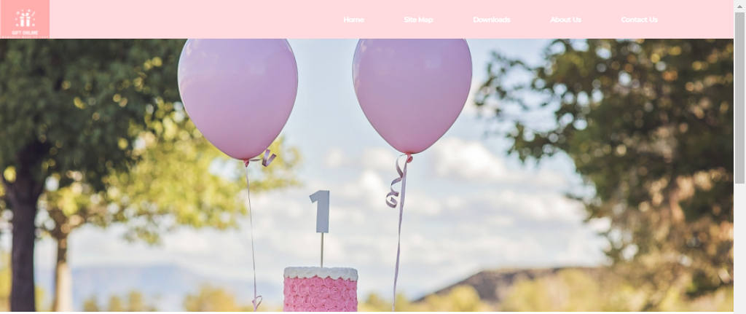

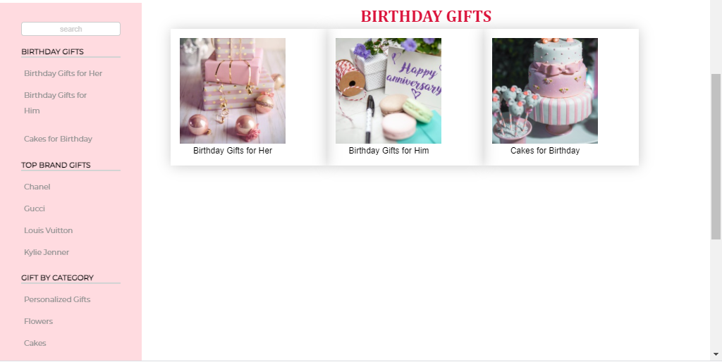

### Birthday Gifts for her page

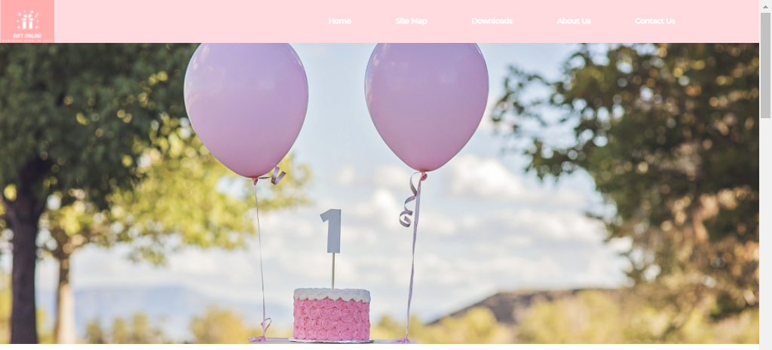

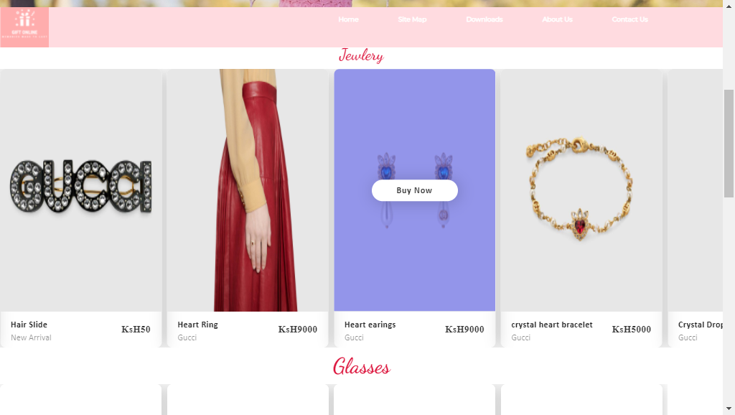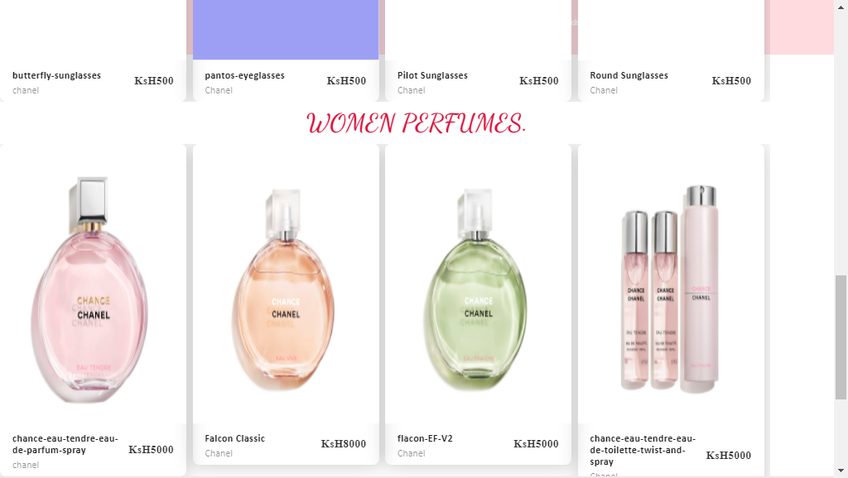

**­­**

### Birthday Gifts for him page

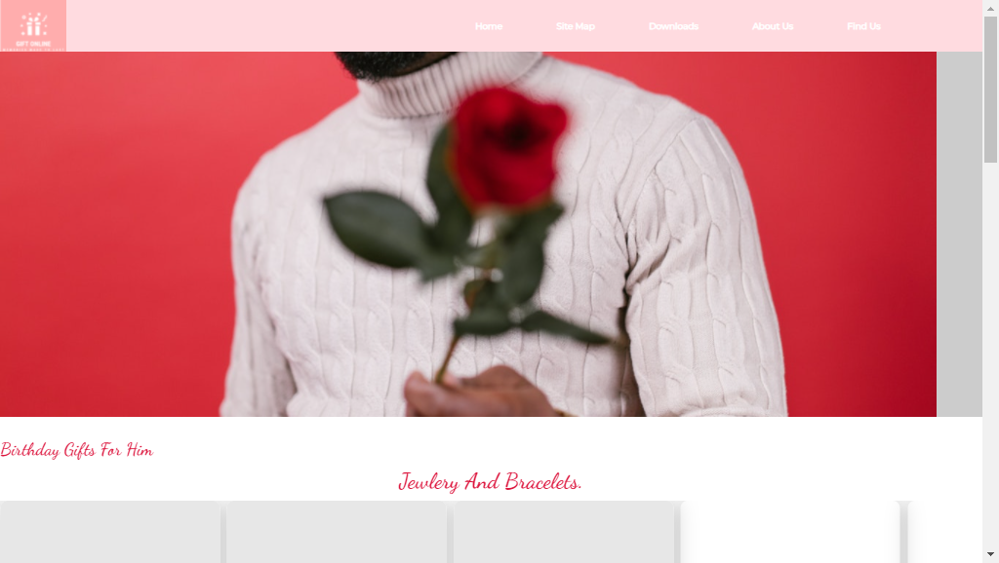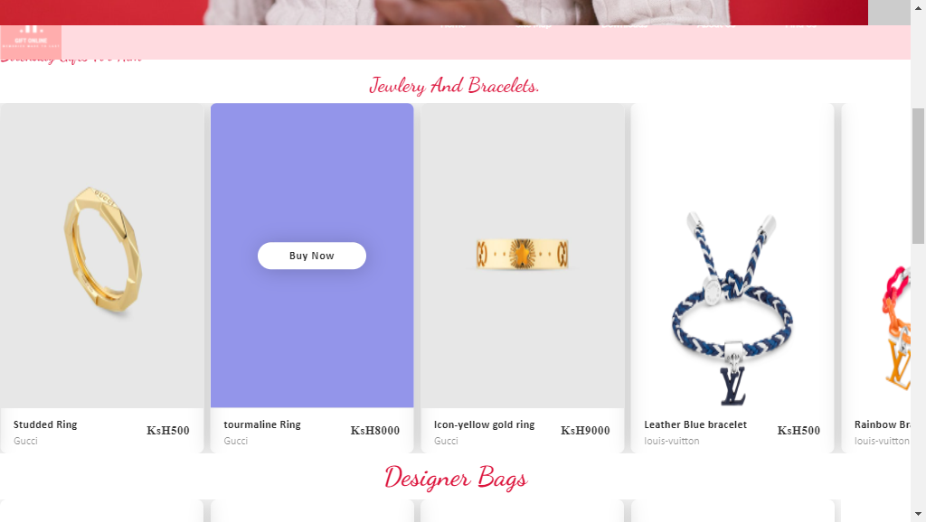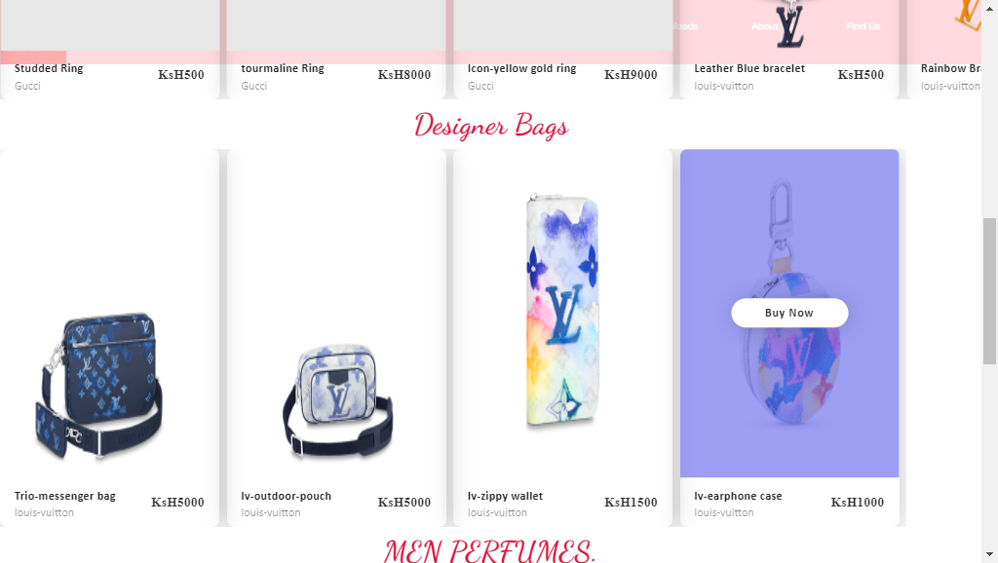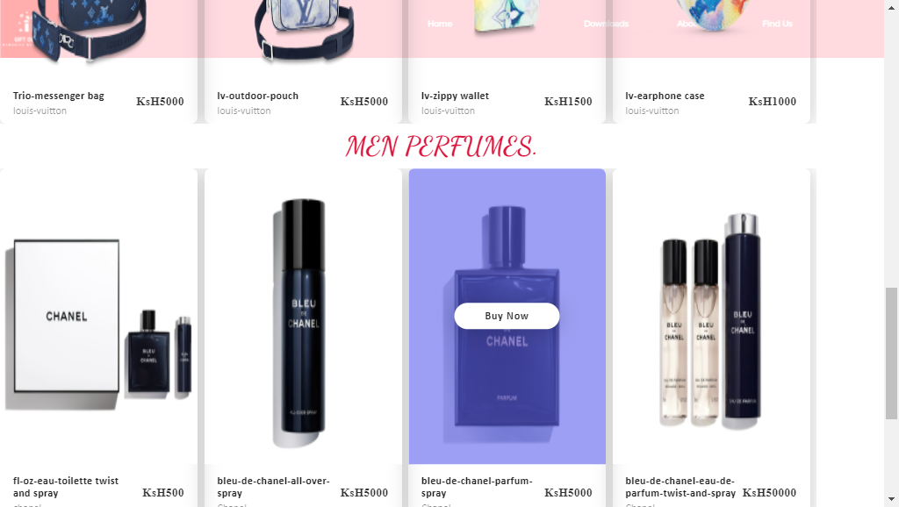

### Cakes For Birthday

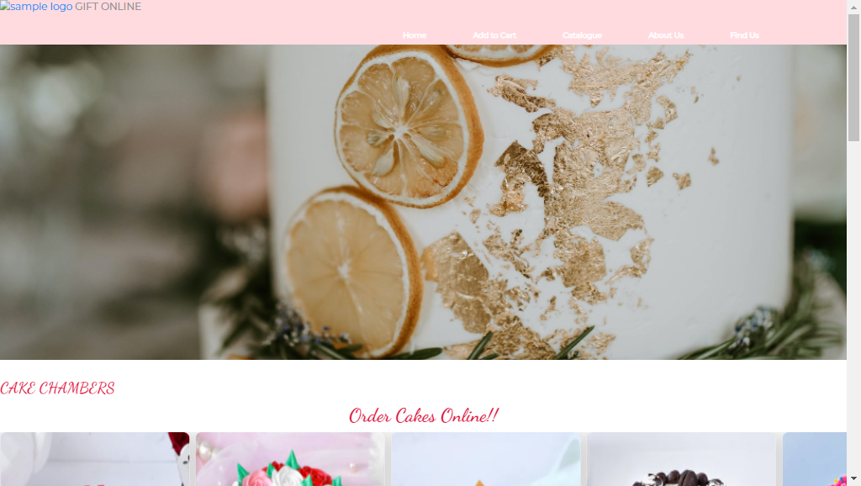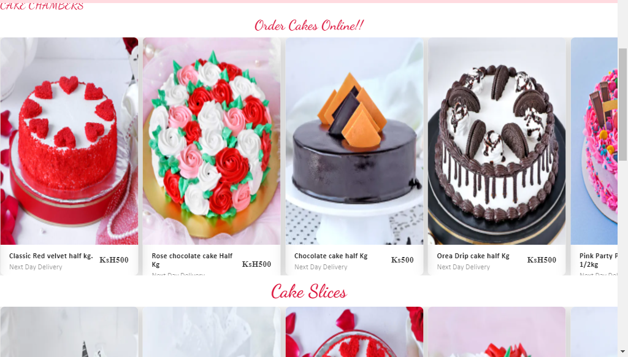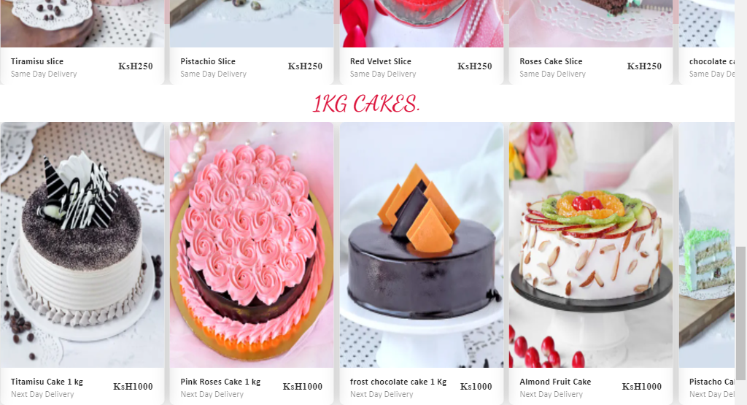

### Top Brands

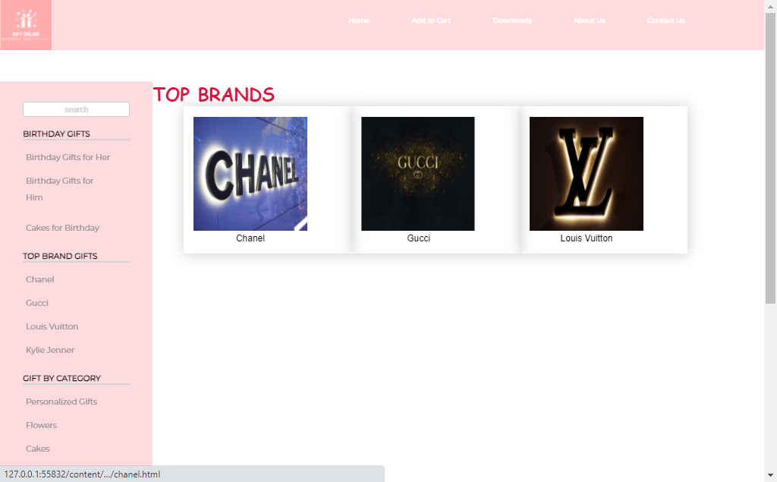

### Chanel

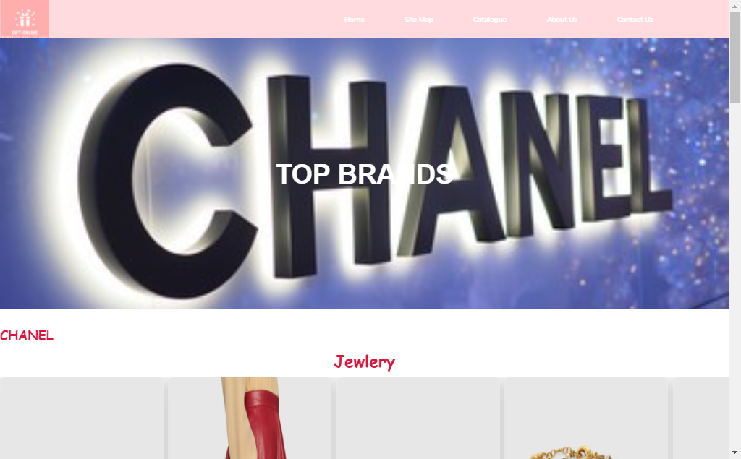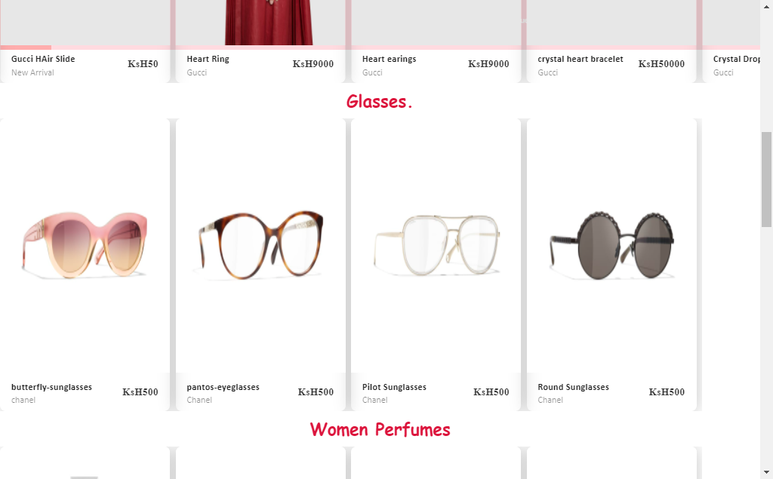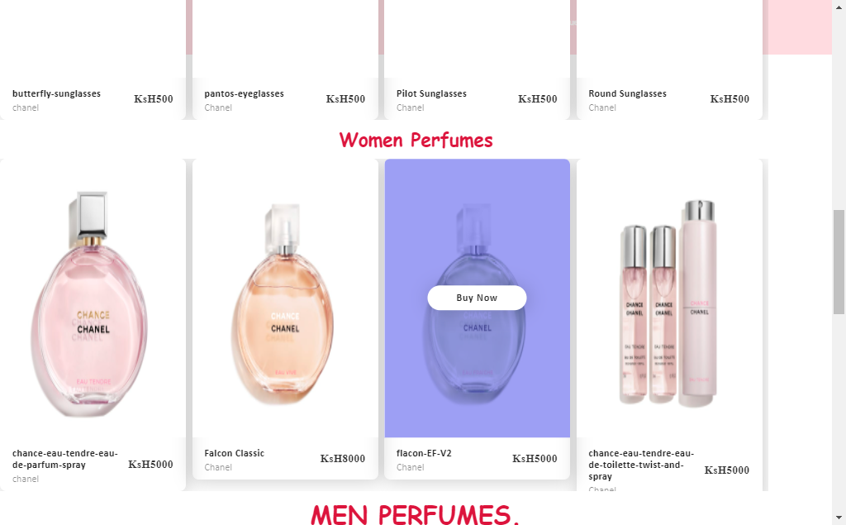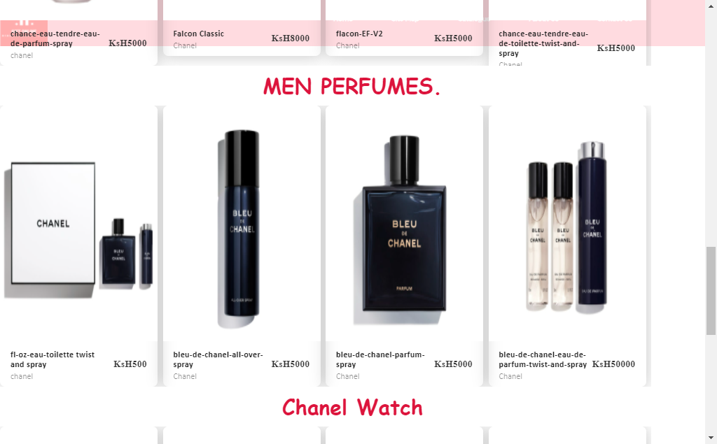

### Gucci Page

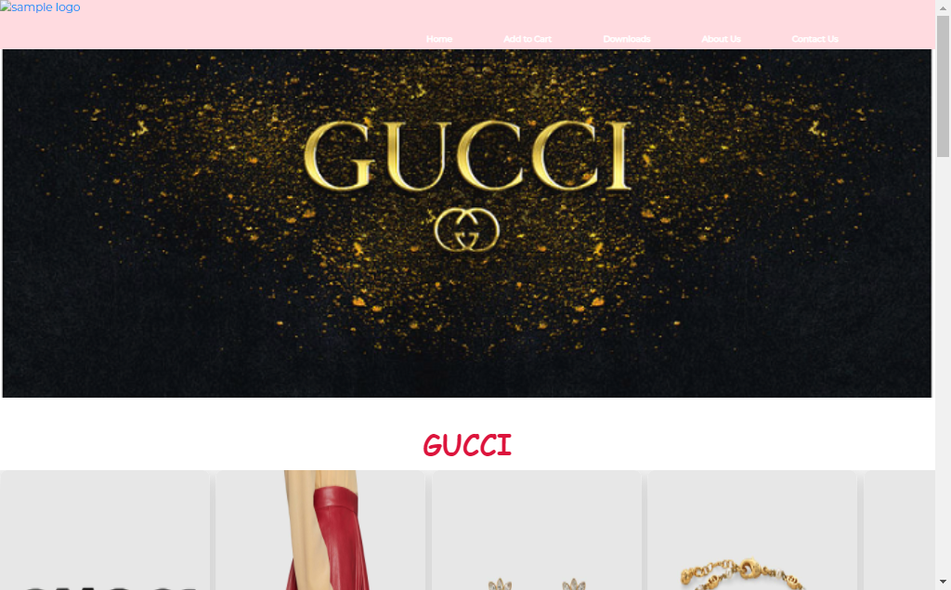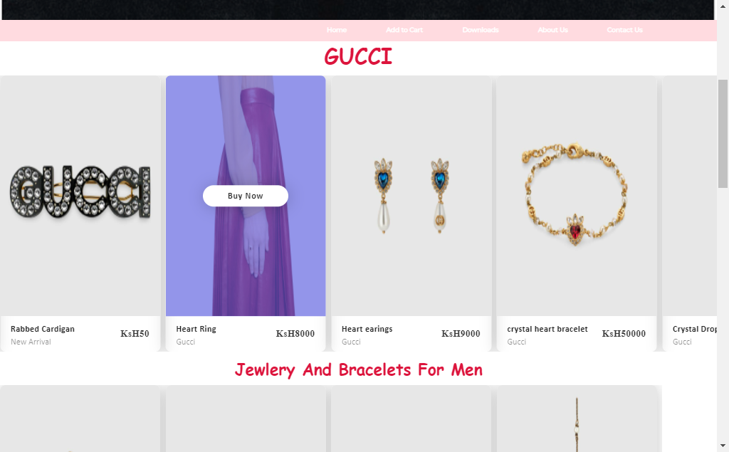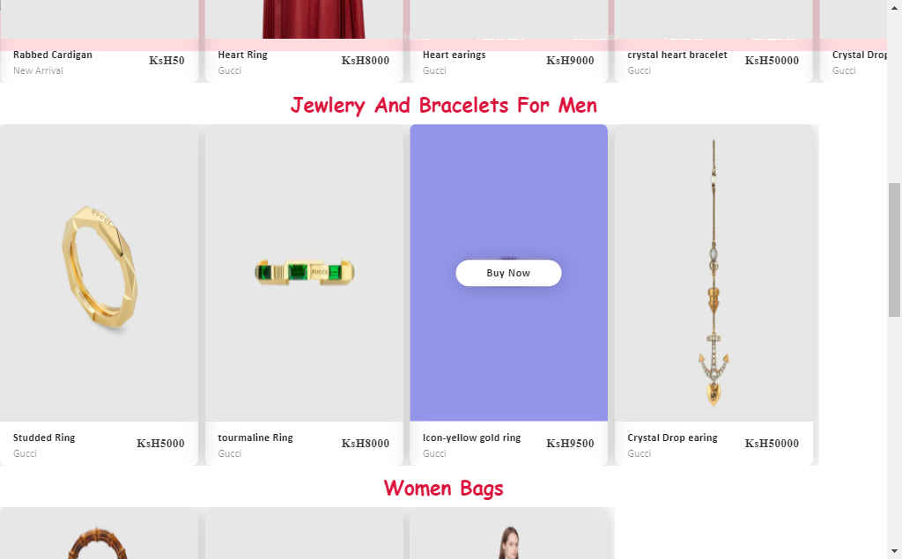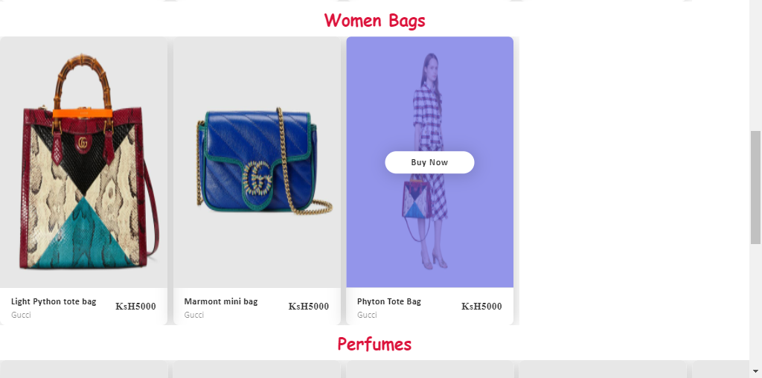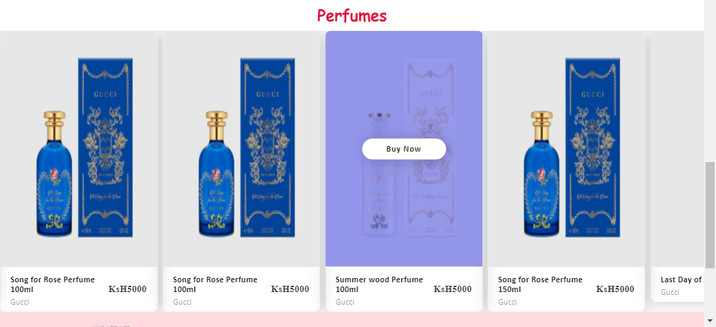

### Louis Vuitton Page



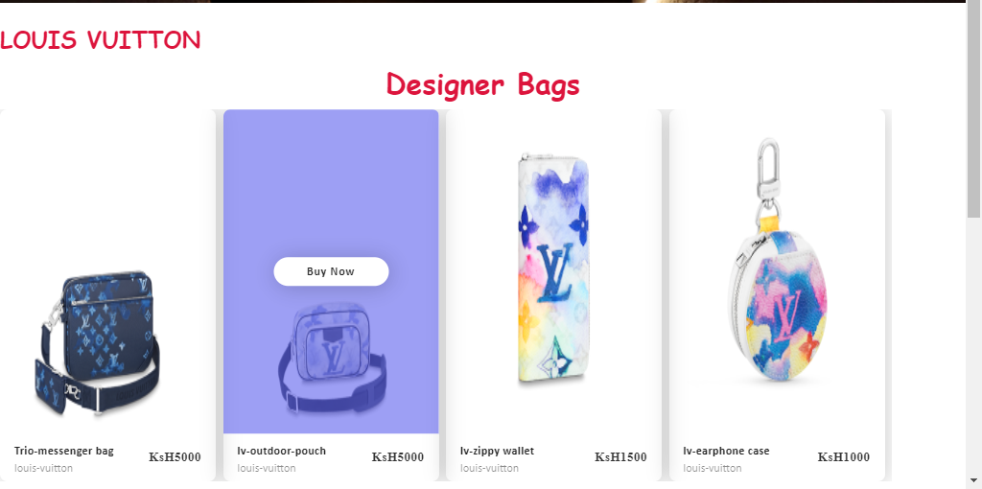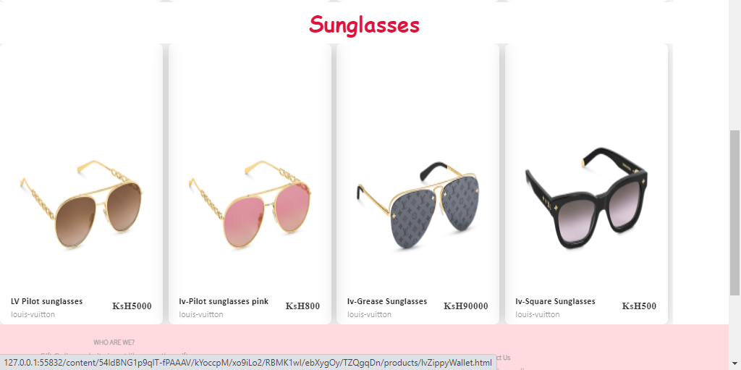

### Gifts By Category

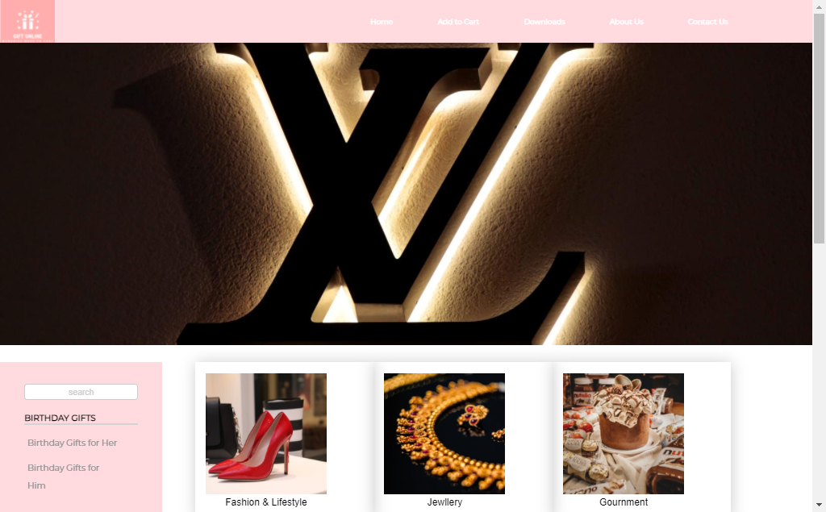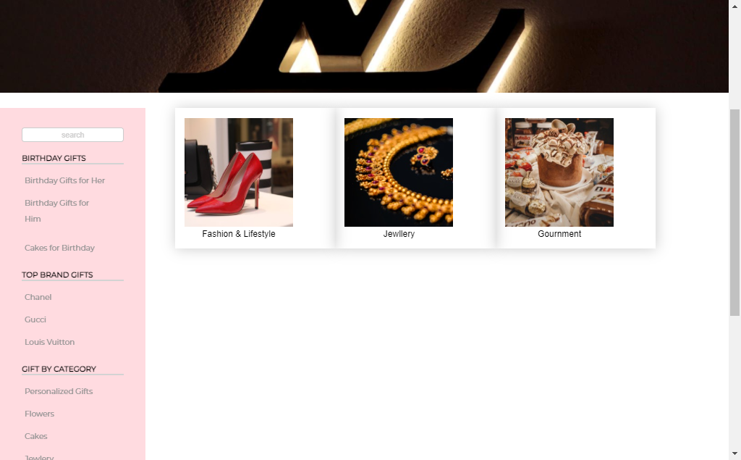

### Personalized Gifts page

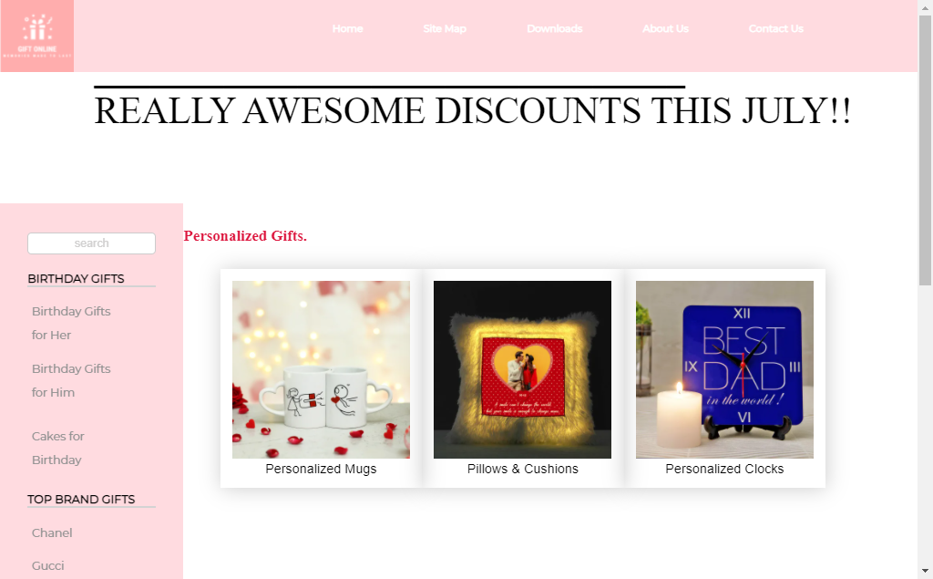

### Personalized Mugs Page

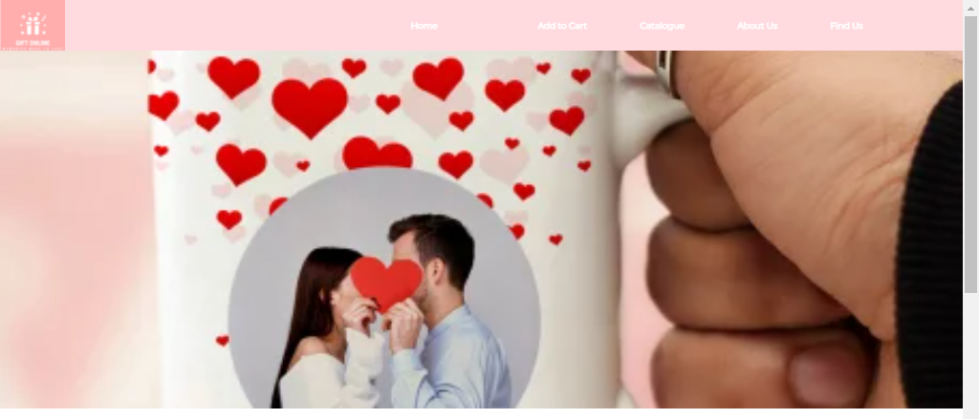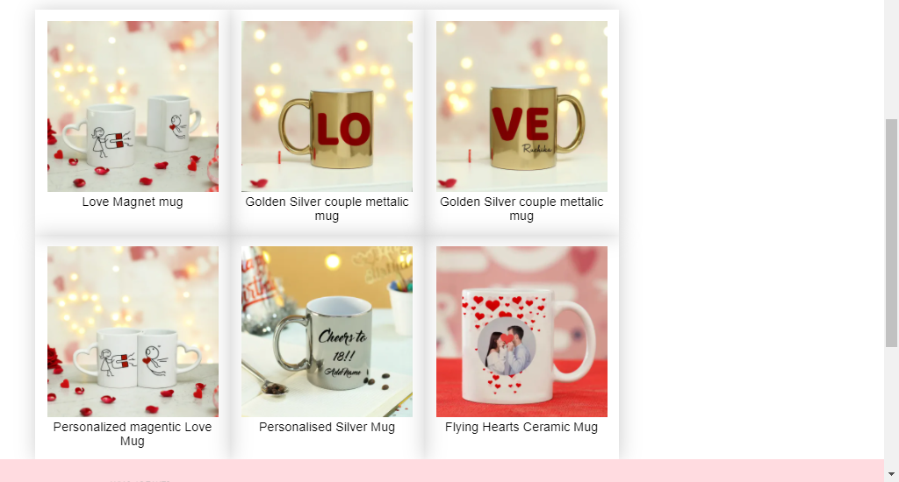

### Personalized Cushions and Pillows Page

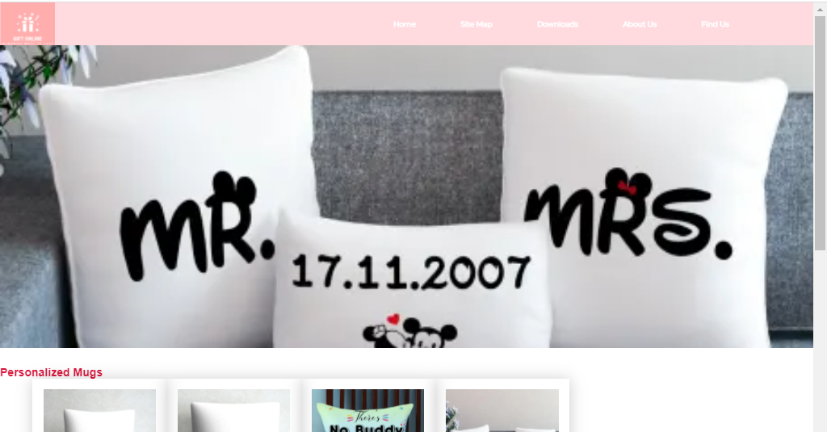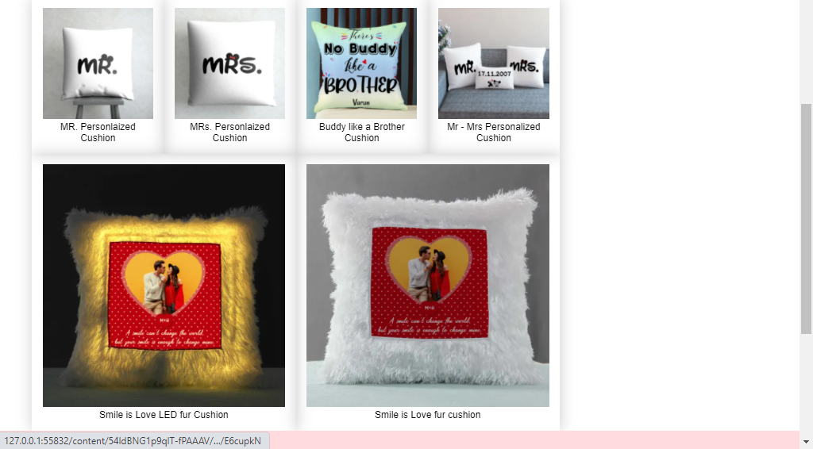

### Personalized Clocks Page

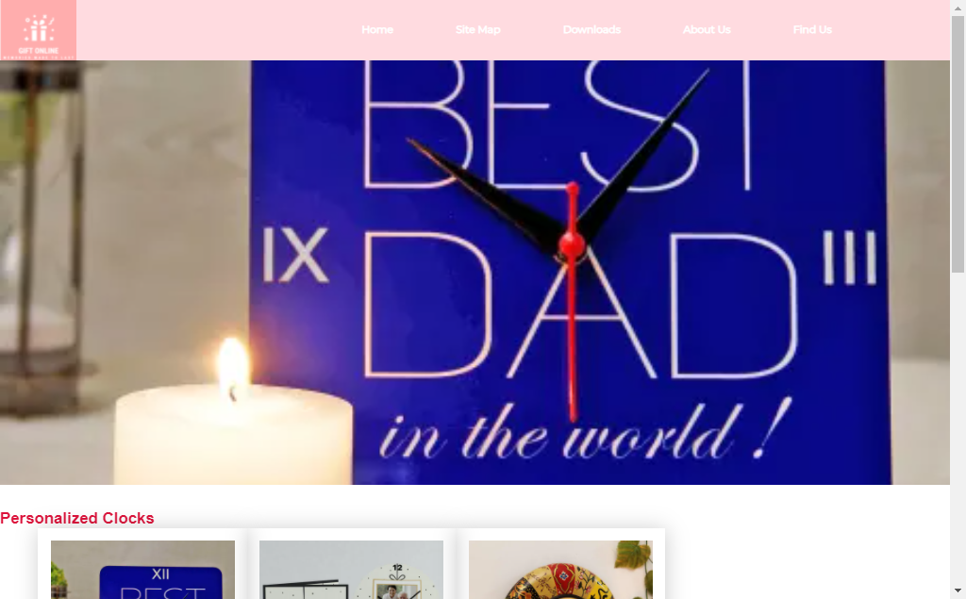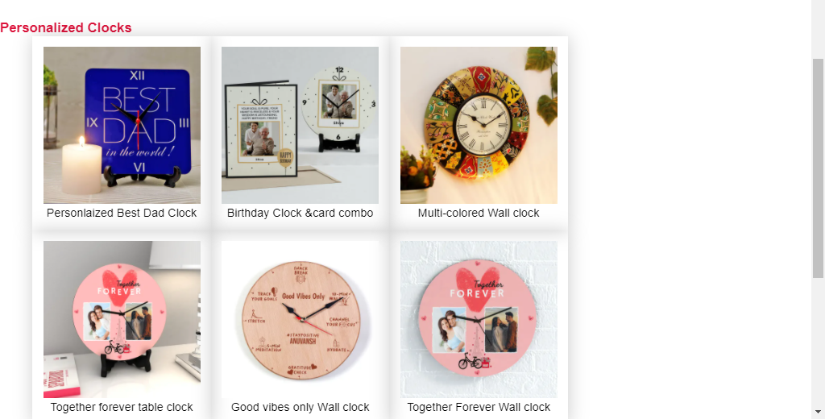

### Flowers Page

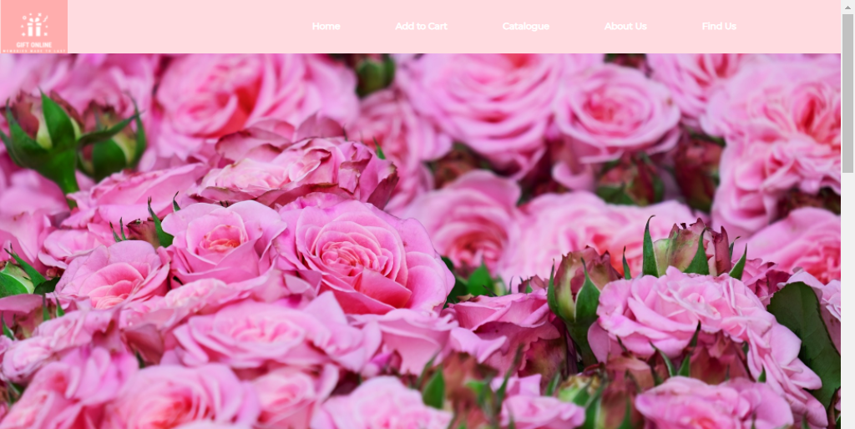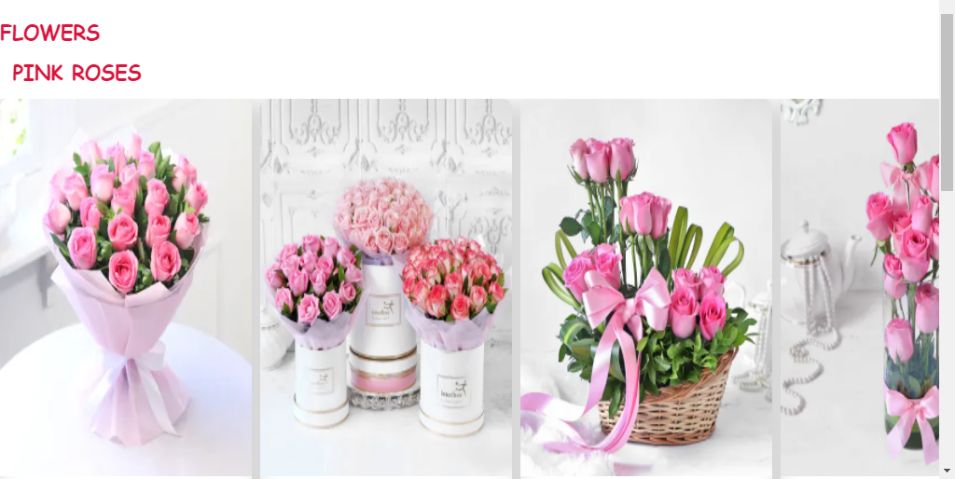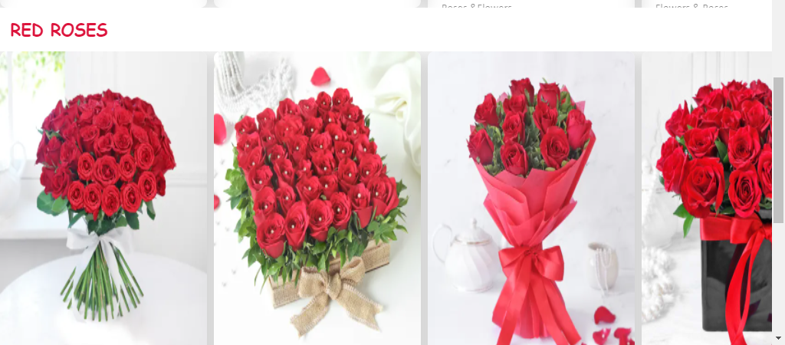

### Pink Roses Page

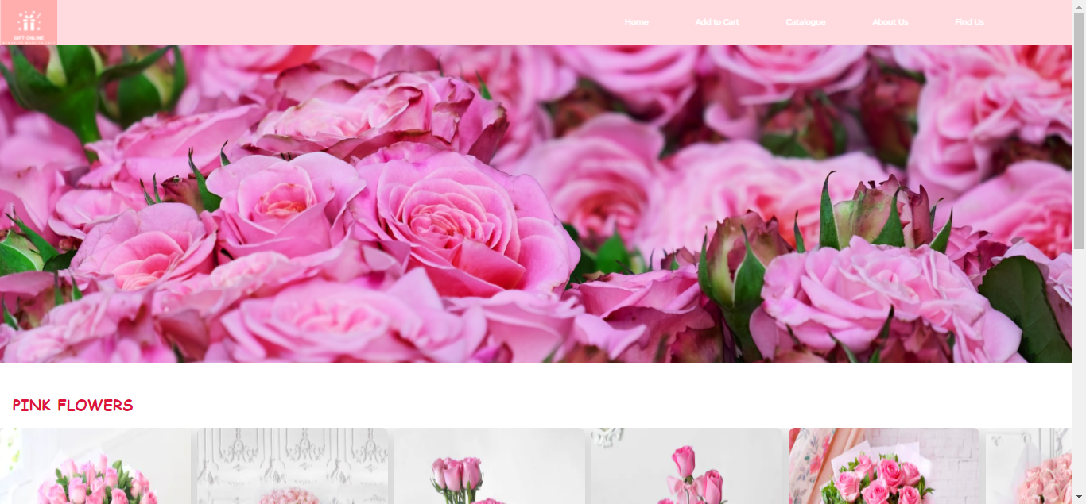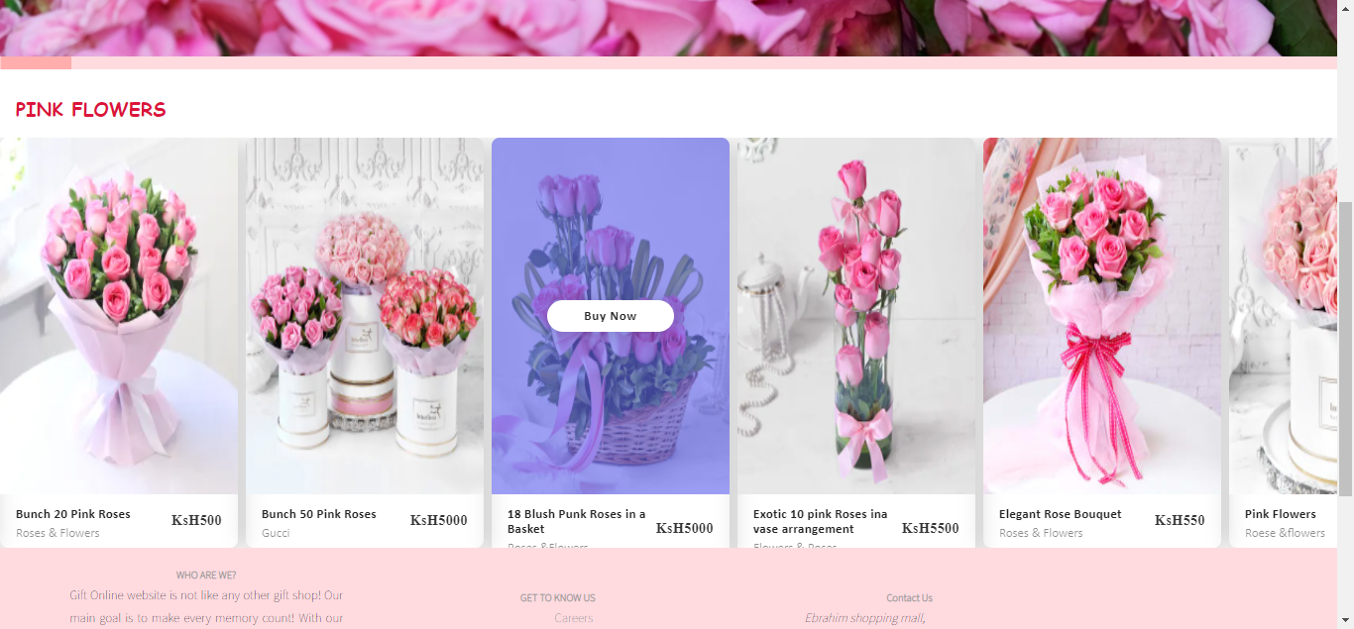

### Red Roses Page

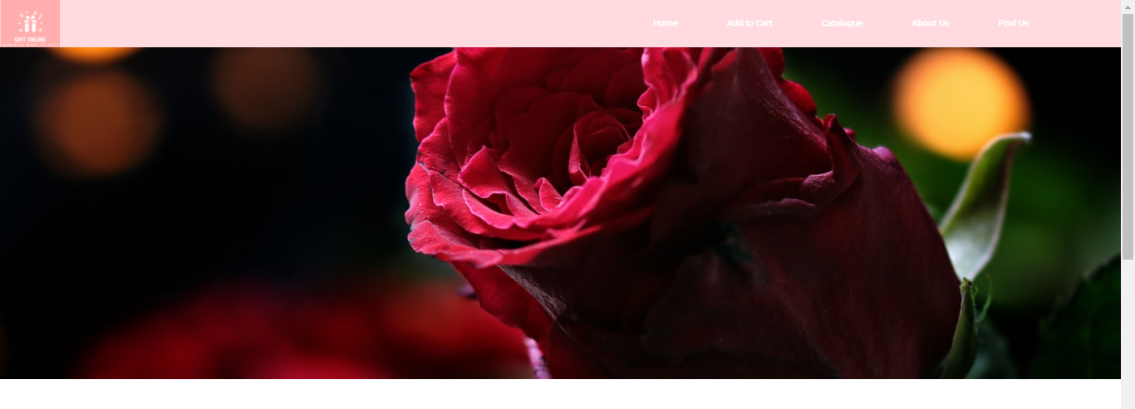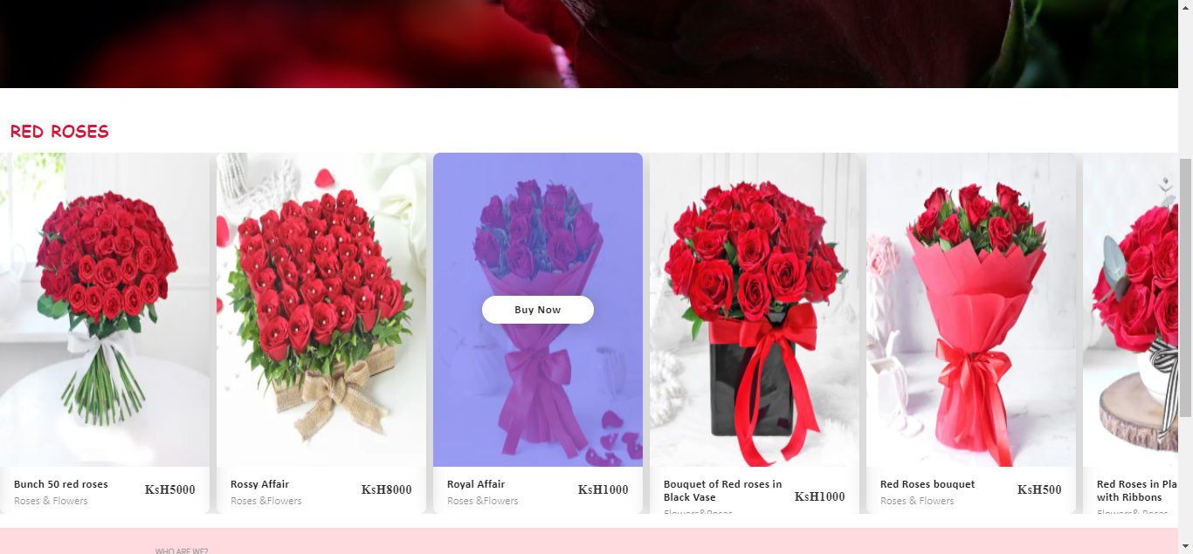

### Cakes Page



### Jewelry Page

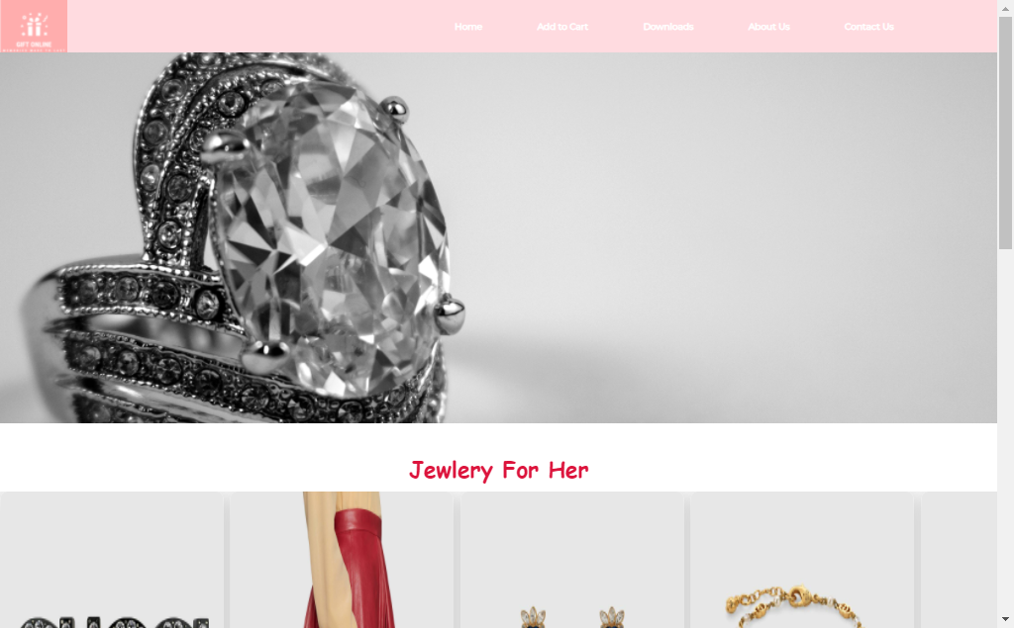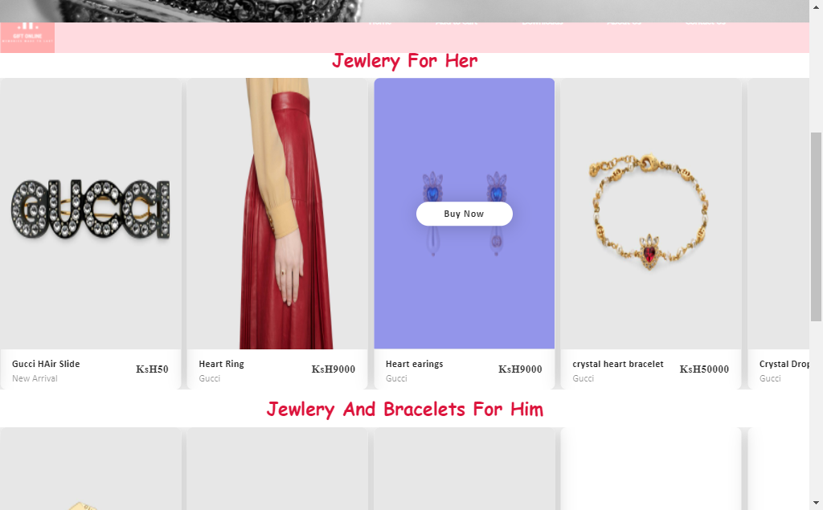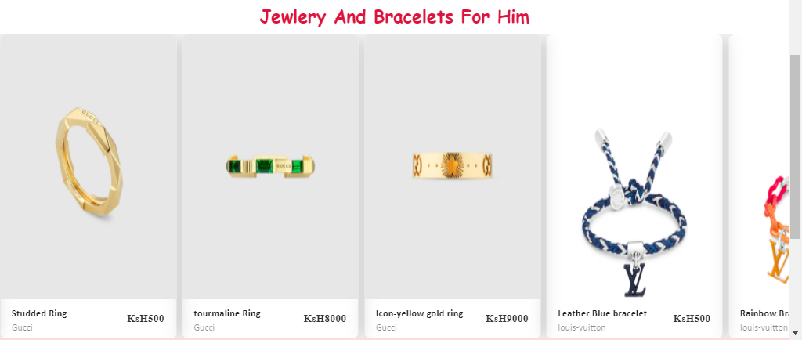

### Download page

1. 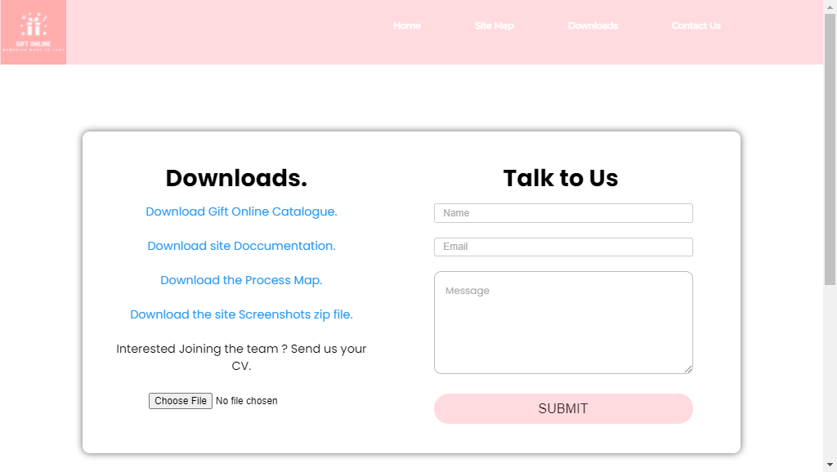

## Source code with comments

## The html code use in the home page

<!doctype html>

<html>

<head>

<meta charset="utf-8">

<title>Gift Online</title>

<link rel="icon" href="/imgs/logoSample.PNG">

<meta name="viewport" content="width=device-width, initial-scale=1">

<link href="assets/styles/style.css.css" rel="stylesheet" type="text/css">

<!--The following script tag downloads a font from the Adobe Edge Web Fonts server for use within the web page. We recommend that you do not modify it.-->

<script>var __adobewebfontsappname__="dreamweaver"</script><script src="http://use.edgefonts.net/montserrat:n4:default;source-sans-pro:n2:default.js" type="text/javascript"></script>

<!-- Add icon library -->

<link rel="stylesheet" href="https://cdnjs.cloudflare.com/ajax/libs/font-awesome/4.7.0/css/font-awesome.min.css">

<style>

/* COMPANY TEAM SECTION.*/

.team{

list-style:none;

align-content:center;

text-align: center;

padding-bottom: 20px;

margin-top: 10px;

font-family: allura;

font-size: 25px;

}

</style>

<!--END OF COMPANY TEAM SECTION STYLING-->

<!-- 2nd header styling-->

<style>

.hero-image {

margin-top: 71px;

background-image: url("imgs/homeBanner.jpg");

background-color: #cccccc;

height: 500px;

background-position:center;

background-repeat: no-repeat;

background-size:cover;

position: relative;

}

.hero-text {

text-align: left;

position: absolute;

top: 50%;

left: 50%;

transform: translate(-50%, -50%);

color: white;

}

</style>

<!-- End of second header styling-->

</head>

<body>

<div id="mainWrapper">

<header class="sticky">

<div class="logo">

<img src="../imgs/logoSample.PNG" alt="logo">

</div>

<div id="headerLinks"><a href="index.html.html" title="Home">Home</a>

<a href="pages/sitemap.html" title="Site Map">Site Map</a>

<a href="pages/downloads.html" title="Download our catalogue">Downloads</a>

<a href="pages/aboutUs.html" title="About us">About Us</a>

<a href="pages/findUs.html" title="Find us">Contact Us</a>

</div>

</header>

<!-- header content-->

<div class="hero-image">

<div class="hero-text">

<!--

<h1 style="font-size:10px">LOUIS VUITTON</h1>

<h3>!!</h3>

<button>Start Buying</button>

-->

</div>

</div>

<!-- End of header content-->

<div id="content">

<section class="sidebar">

<!-- This adds a sidebar with 1 searchbox,2 menusets, each with 4 links -->

<input type="text" id="search" value="search">

<div id="menubar">

<nav class="menu">

<a href="pages/birthdayGifts.html" title="Birthday Gifts" ><h2><!-- Title for menuset 1 -->BIRTHDAY GIFTS </h2></a>

<hr>

<ul>

<!-- List of links under menuset 1 -->

<li><a href="pages/birthdayGiftsForHer.html" title="Birthday Gifts for Her">Birthday Gifts for Her&nbsp;♥</a> </li>

<li><a href="pages/birthdayGiftsForHim.html" title="Birthday Gifts for Him">Birthday Gifts for Him</a></li>

<li><a href="#" title="Cakes for Birthdays"></a></li>

<li class="notimp"><!-- notimp class is applied to remove this link from the tablet and phone views --><a href="pages/cakes.html" title="Cakes for Birthday">Cakes for Birthday</a></li>

</ul>

</nav>

<nav class="menu">

<a href="pages/topBrandGifts.html" title="Top Brand Gifts"><h2><!-- Title for menuset 1 -->TOP BRAND GIFTS </h2></a>

<hr>

<ul>

<!-- List of links under menuset 1 -->

<li><a href="pages/chanel.html" title="Chanel">Chanel</a></li>

<li><a href="pages/gucci.html" title="Gucci">Gucci</a></li>

<li><a href="pages/louisVuitton.html" title="Louis Vuitton">Louis Vuitton</a></li>

<!-- <li class="notimp"> notimp class is applied to remove this link from the tablet and phone views <a href="pages/kylieJenner.html" title="Kylie Jenner">Kylie Jenner</a></li>-->

</ul>

</nav>

<nav class="menu">

<a href="pages/giftByCategory.html" title="GIFT BY CATEGORY"><h2>GIFT BY CATEGORY </h2></a>

<!-- Title for menuset 2 -->

<hr>

<ul>

<!--List of links under menuset 2 -->

<li><a href="pages/personalizedGifts.html" title="Personalized Gifts">Personalized Gifts</a></li>

<li><a href="pages/flowers.html" title="Flowers">Flowers</a> </li>

<li><a href="pages/cakes.html" title="Cakes">Cakes</a></li>

<li class="notimp"><!-- notimp class is applied to remove this link from the tablet and phone views --><a href="pages/jewlery.html" title="Jewlery">Jewlery</a></li>

</ul>

</nav>

</div>

</section>

<!-- section 2------------------------------------------------------------------>

<section> <h2 style="margin: 20px;font-family: bitter;">COMPANY TEAM</h2>

<hr>

<ul><li class="team">Elisha Mukhule</li></ul>

<hr style="padding-top: 10px;padding-bottom: 10px;">

</section>

<!-- Category card 1-->

<div class="category-row">

<section class="mainContent category">

<div class="card category-card" style="width: 18rem;">

<div class="category-img">

<figure><a href="pages/birthdayGifts.html" title="Birthday Gifts"><img class="card-img-top" src="imgs/birthday_2.jpg" alt="Card image cap" style="width:100%" height="auto"></a>

<figcaption>Birthday Gifts</figcaption>

</figure>

</div>

</div>

<!------category Card 2----->

<div class="card category-card" style="width: 18rem;">

<div class="category-img">

<figure><a href="#" title="Anniversary Gifts"><img class="card-img-top" src="imgs/anniversary.jpg" alt="Card image cap" style="width: 100%" height="auto"></a>

<figcaption>Anniversary Gifts</figcaption>

</figure>

</div>

</div>

<!------category Card 3----->

<div class="card category-card" style="width: 18rem;">

<div class="category-img">

<figure><a href="pages/giftsForWomen.html" title="Gifts for women"><img class="card-img-top" src="imgs/pexels-jill-wellington-3264665.jpg" alt="Card image cap" style="width: 100%" height="auto"></a>

<figcaption>Gifts for Women</figcaption>

</figure>

</div>

</div>

<!------category Card 4----->

<div class="card category-card" style="width: 18rem;">

<div class="category-img">

<figure><a href="pages/giftsFormen.html" title="Gifts for men"><img class="card-img-top" src="imgs/gifts4men200.jpg" alt="Card image cap" style="width: 100%" height="auto"></a>

<figcaption>Gifts for Men</figcaption>

</figure>

</div>

</div>

<!------category Card 5----->

<div class="card category-card" style="width: 18rem;">

<div class="category-img">

<figure><a href="pages/chocolate.html.html" title="Chocolates"><img class="card-img-top" src="imgs/chocolates.jpg" alt="Card image cap" style="width:100%" height="auto"></a>

<figcaption>Chocolates</figcaption>

</figure>

</div>

</div>

<!------category Card 6----->

<div class="card category-card" style="width: 18rem;">

<div class="category-img">

<figure><a href="pages/cakes.html" title="Cakes"><img class="card-img-top" src="imgs/cakes.jpg" alt="Card image cap" style="width: 100%" height="auto"></a>

<figcaption>Cakes</figcaption>

</figure>

</div>

</div>

<!------category Card 8----->

<div class="card category-card" style="width: 18rem;">

<div class="category-img">

<figure><a href="pages/sameDayDelivery.html" title="Same Day Delivery"><img class="card-img-top" src="imgs/sameDayDelivery.jpg" alt="Card image cap" style="width: 100%" height="auto"></a>

<figcaption>Same Day Delivery</figcaption>

</figure>

</div>

</div>

<!------category Card 9----->

<div class="card category-card" style="width: 18rem;">

<div class="category-img">

<figure><a href="pages/topBrandGifts.html" title="Top brands"><img class="card-img-top" src="imgs/topBrands.jpg" alt="Card image cap" style="width:100%" height="auto"></a>

<figcaption>Top Brands for him/her</figcaption>

</figure>

</div>

</div>

</section>

</div>

<!-- end of section 2---------------------------------------------------------->

<!--

<div class="section-heading">

<h4>PRODUCT GALLERY</h4>

</div>

-->

</div>

<footer>

<div> <a href="index.html">

<h5>WHO ARE WE?</h5>

</a>

<p style="color: black;">Gift Online website is not like any other gift shop! Our main goal is to make every memory count! With our variety of authentic gifts.</p>

</div>

<p>&nbsp;</p>

<div> <a href="pages/aboutUs.html">

<h5>GET TO KNOW US</h5>

</a>

<ul style="list-style: none;">

<a href="#">

<li>Careers</li>

</a> <a href="#">

<li>About US</li>

</a> <a href="#">

<li>Privacy Policy</li>

</a> <a href="mailto:mukhulee@gmail.com">Send Us an Email </a>

</ul>

</div>

<div>

<h5 style="align-content:flex-end"> <a href ="pages/findUs.html" title="Contact us">Contact Us</a></h5>

<ul style="list-style: none;">

<address>

<li style="color: black;">Ebrahim shopping mall,<br>

First Floor suite E9<br>

Moi avenue street<br>

Nairobi,Kenya.</li>

</address>

</ul>

<p></p>

</div>

<br>

<br>

<div class="footerlinks">

<h5 style="color: black">Follow Us</h5>

<a href="#" class="fa fa-facebook"></a> <a href="https://twitter.com/home" class="fa fa-twitter" target="_blank"></a> <a href="https://www.linkedin.com/in/elisha-mukhule-564643145?lipi=urn%3Ali%3Apage%3Ad_flagship3_profile_view_base_contact_details%3Boj3daNYJR36Pu74ZwChatQ%3D%3D" class="fa fa-linkedin" target="_blank"></a> <a href="https://www.instagram.com/emukhule_101/" class="fa fa-instagram" target="_blank"></a> </div>

<div class="font-12">

<p>&nbsp;</p>

<p>&nbsp;</p>

<p>&nbsp;</p>

<p>&nbsp;</p>

<p>&nbsp;</p>

<p style="color: black;"><a href="pages/sitemap.html">Site map</a></p>

<p style="color: black;">copyright&copy;2021.giftonline.com All rights reserved.</p>

</div>

<!--CONTENT DIV END -->

</footer>

</div>

<!--CONTENT DIV END -->

</body>

</html>

## Html code used in the Site Map page, contact page, about us page and download page

## Contact page code

<!doctype html>

<html>

<head>

<meta charset="utf-8">

<title>Gift Online</title>

<meta name="viewport" content="width=device-width, initial-scale=1">

<link href="../assets/styles/style.css.css" rel="stylesheet" type="text/css">

<!--The following script tag downloads a font from the Adobe Edge Web Fonts server for use within the web page. We recommend that you do not modify it.-->

<script>var __adobewebfontsappname__="dreamweaver"</script><script src="http://use.edgefonts.net/montserrat:n4:default;source-sans-pro:n2:default.js" type="text/javascript"></script>

<link rel="preconnect" href="https://fonts.googleapis.com">

<link rel="preconnect" href="https://fonts.gstatic.com" crossorigin>

<link href="https://fonts.googleapis.com/css2?family=Poppins:ital,wght@0,400;0,600;0,700;1,300;1,900&display=swap" rel="stylesheet">

<!-- Add icon library -->

<link rel="stylesheet" href="https://cdnjs.cloudflare.com/ajax/libs/font-awesome/4.7.0/css/font-awesome.min.css">

</head>

<body>

<div id="mainWrapper">

<header class="sticky">

<!-- This is the header content. It contains Logo and links -->

<div class="logo">

<img src="../imgs/logoSample.PNG" alt="logo">

</div>

<div id="headerLinks"><a href="../index.html" title="Home">Home</a> <a href="sitemap.html" title="Site Map">Add to Cart</a> <a href="downloads.html" title="Download our catalogue">Downloads</a>

<!-- <a href="#" title="Find us">About Us</a>-->

<a href="findUs.html" title="Contact Us">Contact Us</a> </div>

</header>

<div id="content">

<div id="contacts_us">

<div class="contact-in"> `

<div class="contact-map">

<iframe src="https://www.google.com/maps/embed?pb=!1m18!1m12!1m3!1d3988.817678589742!2d36.82087031415741!3d-1.283244635983332!2m3!1f0!2f0!3f0!3m2!1i1024!2i768!4f13.1!3m3!1m2!1s0x182f10d5d9e616eb%3A0xcc6fb74a87e9df6f!2sEbrahim%20%26%20Co%20Ltd!5e0!3m2!1sen!2ske!4v1628061823334!5m2!1sen!2ske" width="100%" height="auto" style="border:0;" allowfullscreen="" loading="lazy"></iframe>

</div>

<div class="contact-form">

<h1>Contact Us</h1>

<form>

<input type="text" placeholder="Name" class="contact-form-text" />

<input type="text" placeholder="Email" class="contact-form-text" />

<a href="mailto:mukhulee@gmail.com">Send Us an Email </a>

<textarea placeholder="Message" class="contact-form-textarea" ></textarea>

<input type="submit" placeholder="Submit" class="contact-form-btn"/>

</form>

</div>

</div>

</div>

<footer>

<div> <a href="index.html">

<h5>WHO ARE WE?</h5>

</a>

<p style="color: black;">Gift Online website is not like any other gift shop! Our main goal is to make every memory count! With our variety of authentic gifts.</p>

</div>

<p>&nbsp;</p>

<div> <a href="pages/aboutUs.html">

<h5>GET TO KNOW US</h5>

</a>

<ul style="list-style: none;">

<a href="#">

<li>Careers</li>

</a> <a href="#">

<li>About US</li>

</a> <a href="#">

<li>Privacy Policy</li>

</a> <a href="mailto:mukhulee@gmail.com">Send Us an Email </a>

</ul>

</div>

<div>

<h5 style="align-content:flex-end"> <a href ="pages/findUs.html" title="Contact us">Contact Us</a></h5>

<ul style="list-style: none;">

<address>

<li style="color: black;">Ebrahim shopping mall,<br>

First Floor suite E9<br>

Moi avenue street<br>

Nairobi,Kenya.</li>

</address>

</ul>

<p></p>

</div>

<br>

<div class="footerlinks">

<h5 style="color: black">Follow Us</h5>

<a href="#" class="fa fa-facebook"></a> <a href="https://twitter.com/home" class="fa fa-twitter" target="_blank"></a> <a href="https://www.linkedin.com/in/elisha-mukhule-564643145?lipi=urn%3Ali%3Apage%3Ad_flagship3_profile_view_base_contact_details%3Boj3daNYJR36Pu74ZwChatQ%3D%3D" class="fa fa-linkedin" target="_blank"></a> <a href="https://www.instagram.com/emukhule_101/" class="fa fa-instagram" target="_blank"></a> </div>

<div class="font-12">

<p>&nbsp;</p>

<p>&nbsp;</p>

<p>&nbsp;</p>

<p>&nbsp;</p>

<p>&nbsp;</p>

<p style="color: black;">copyright&copy;2021.giftonline.com All rights reserved.</p>

</footer>

</div>

</div>

</body>

</html>

## About us code

<!DOCTYPE HTML>

<HTML>

<head>

<title>Ceiling Fans</title>

<link href="../css/slider.css" rel="stylesheet">

<link rel = "stylesheet" type = "text/css" href = "../css/Exp.css">

<link rel = "stylesheet" type = "text/css" href = "../css/commonBg.css">

<link rel= "stylesheet" type="text/css" href="../css/HomeCss.css">

<script src="../js/slider.js"></script>

<meta charset="utf-8">

<meta http-equiv="X-UA-Compatible" content="IE=edge">

<meta name="viewport" content="width=device-width, initial-scale=1">

</head>

<body>

<nav>

<ul>

<li><a href = "..\FanHomePage.html"> Home </a></li>

<li class="dropdown">

<a href="#" class="dropbtn">Shop</a>

<div class="dropdown-content">

<a href="../Pages/TableFans.html">Table Fans</a>

<a href="../Pages/Ceiling.html">Ceiling Fans</a>

<a href="../Pages/windowfans.html">Window Fans</a>

<a href="../Pages/wall Mount.html">Wall Mount Fans</a>

<a href="../Pages/Floorfans.html">Floor Fans</a>

<a href="../Pages/Tower.html">Tower Fans</a>

<a href="../Pages/Box fans.html">Box Fans</a>

<a href="../pages/mistingFans.html">Misting Fans</a>

<a href="../Pages/IndustrialFans.html">Industrial Fans and blowers</a>

<a href="../Pages/Decorative.html">Decorative Fans</a>

<a href="../Pages/bathroom.html">Bathroom Exhaust Fans</a>

</div>

</li>

<li><a href = "contact.html"> Contact</a></li>

<li><a href = "gallery.html">Gallery</a></li>

<li><a href = "../Pages/downloads.html"> Downloads </a></li>

</ul>

</nav>

<header id="About">

<a href="../FanHomePage.html">

<img class = "logo" src = "..\images\Fan o Fan Logo.png">

</a>

<div class="container2">

<div class="intro-text">

<div class="intro-lead-in"></div>

</div>

</div>

</header>

<div>

<h1>FANoFAN</h1>

<p>It is a company that is specialized in selling fans.We sell all kinds of fans.

We are nine years old now and we have different sites in the country to ensure that we reach all our customers</p>

</div>

<div>

<h1>Our Aim</h1>

<p>To Change the Lives Of People From Living To The Standard Of Their Basics To Their Luxury Living By Providing All Types Of Quality Fans.</p>

</div>

<div>

<h1>Our Core Values</h1>

<br>

<ul>

<li>Customer first</li><br>

<li>Team work</li><br>

<li>Passion</li><br>

<li>Integrity</li><br>

<li>Excellence</li><br>

</ul>

</div>

<br>

<div>

<h1>Our Quality Policy</h1>

<p>FANoFAN is committed to providing high quality customer services by efficiently distributing high quality fans <br> that are safe, adequate and reliable at an affordable cost .The board of directors and management are committed to effectively <br> supplying quality products to meet the customers needs and expectations. </p>

</div>

<div id="slider" style="right:-342px;">

<div id="sidebar" onclick="open_panel()">Click!<br>Me</div>

<div id="header">

<h2>Want to know more about us</h2>

<p>Ask more about Us!</p>

<input name="dname" type="text" value="Your Name">

<input name="demail" type="text" value="Your Email">

<h4>Type of Question</h4>

<select>

<option>General Question</option>

<option>Mulfunctionality</option>

<option>Technical</option>

<option>Job Application</option>

<option>Others</option>

</select>

<textarea>Message</textarea>

<button>Send Message</button>

</div>

</div>

<!--Order button section-->

<div class="back">

<p>Click the button to start the ordering Process Now</p>

<br>

<br>

<a href="order.html"><div class="button b11_3d_jumpback">

<div>Order Here</div></a>

</div>

</div>

<!--Footer-->

<div class="foot">

<div class="footer"><strong>Our location </strong><br> Nairobi Kenya ,Kimathi avenue

<br><strong>Email</strong><br> <a href="https://gmail.com _blank">fanofan@gmail.com</a>

</div>

<div class="footer">Telephone Number<br> <strong> 07123456789 </strong>

</div>

<div class="social">

<a href="https://www.facebook.com/Shem-Finally-Speaks-His-Mind-295198954165581/" target="_blank">

<p> <img src="..\images\facebook.jpg" alt=""/> </p></a>

<a href="https://twitter.com/shemie_b"target="_blank">

<p> <img src="..\images\twitter.jpg" alt=""/> </p></a>

<a href="https://instagram.com/shemie_b"target="_blank">

<p> <img src="..\images\instagram.jpg" alt=""/> </p></a>

</div>

</div>

<div class="footer1">Fan o fan <strong> &copy2017 All rights Reserved</strong>

</div>

</body>

</html>

## Download page code

<!doctype html>

<html>

<head>

<meta charset="utf-8">

<title>Gift Online</title>

<link rel="icon" href="/imgs/logoSample.PNG">

<meta name="viewport" content="width=device-width, initial-scale=1">

<link href="../assets/styles/style.css.css" rel="stylesheet" type="text/css">

<!--The following script tag downloads a font from the Adobe Edge Web Fonts server for use within the web page. We recommend that you do not modify it.-->

<script>var __adobewebfontsappname__="dreamweaver"</script><script src="http://use.edgefonts.net/montserrat:n4:default;source-sans-pro:n2:default.js" type="text/javascript"></script>

<link rel="preconnect" href="https://fonts.googleapis.com">

<link rel="preconnect" href="https://fonts.gstatic.com" crossorigin>

<link href="https://fonts.googleapis.com/css2?family=Poppins:ital,wght@0,400;0,600;0,700;1,300;1,900&display=swap" rel="stylesheet">

<!-- Add icon library -->

<link rel="stylesheet" href="https://cdnjs.cloudflare.com/ajax/libs/font-awesome/4.7.0/css/font-awesome.min.css">

</head>

<body>

<div id="mainWrapper">

<header class="sticky">

<!-- This is the header content. It contains Logo and links -->

<div class="logo">

<a href="../index.html"><img src="../imgs/logoSample.PNG" alt="logo"></a>

</div>

<div id="headerLinks"><a href="#" title="Home">Home</a>

<a href="sitemap.html" title="Add to Cart">Site Map</a>

<a href="downloads.html" title="Download our catalogue">Downloads</a>

<!-- <a href="#" title="Find us">About Us</a>-->

<a href="findUs.html" title="Contact Us">Contact Us</a>

</div>

</header>

<div id="content">

<div id="contacts_us"><div class="contact-in">

<div class="contact-map contact-form">

<h1>Downloads. &nbsp;</h1>

<a href="../downloads/Gift Details.docx"><p>Download Gift Online Catalogue.</p></a><br>

<a href="../Doccumentation/GiftOnline Documentation.docx"><p>Download site Doccumentation.</p></a><br>

<a href="../Doccumentation/process_map.docx"><p>Download the Process Map.</p></a><br>

<a href="../downloads/site_ScreenShots.zip"><p>Download the site Screenshots zip file.</p></a><br>

<p>Interested Joining the team ?

Send us your CV.<br><br> <input type="file" placeholder="Cv">

</p>

</div>

<div class="contact-form">

<h1>Talk to Us&nbsp;</h1>

<form>

<input type="text" placeholder="Name" class="contact-form-text" />

<input type="text" placeholder="Email" class="contact-form-text" />

<textarea placeholder="Message" class="contact-form-textarea" ></textarea>

<input type="submit" placeholder="Submit" class="contact-form-btn"/></form>

</div>

</div></div>

<footer>

<!-- This is the footer with default 3 divs -->

<div>

<a href="index.html"><h5>WHO ARE WE?</h5></a>

<p>Gift Online website is not like any other gift shop! Our main goal is to make every memory count! With our variety of authentic gifts.</p>

</div>

<p>&nbsp;</p>

<div>

<a href="pages/aboutUs.html"><h5>GET TO KNOW US</h5></a>

<ul style="list-style: none;">

<a href="downloads.html"><li>Careers</li></a>

<a href="aboutUs.html"><li>About US</li></a>

<a href="#"><li>Privacy Policy</li></a>

<a href="mailto:mukhulee@gmail.com">Send Us an Email </a>

</ul>

</div>

<div>

<h5 style="align-content:flex-end"> <a href ="pages/findUs.html" title="Contact us">Contact Us</a></h5>

<ul style="list-style: none;">

<address>

<li>Ebrahim shopping mall,<br>

First Floor suite E9<br>

Moi avenue street<br>

Nairobi,Kenya.</li>

</address>

</ul>

<p></p>

</div>

<br>

<div class="footerlinks">

<h5>Follow Us</h5>

<a href="#" class="fa fa-facebook"></a>

<a href="#" class="fa fa-twitter"></a>

<a href="https://www.linkedin.com/in/elisha-mukhule-564643145/" target="_blank" class="fa fa-linkedin"></a>

<a href="https://www.instagram.com/emukhule_101/" target="_blank" class="fa fa-instagram"></a>

</div>

<div class="font-12">

<p>&nbsp;</p>

<p>&nbsp;</p>

<p>&nbsp;</p>

<p>&nbsp;</p>

<p>&nbsp;</p>

<p>copyright&copy;2021.giftonline.com All rights reserved.</p>

</div>

</footer></div></div>

</body>

</html>

## USER GUIDE

TO GET STARTED

After login in the site.

Browse through the side menu on the left and Click on the category of gift you want to shop

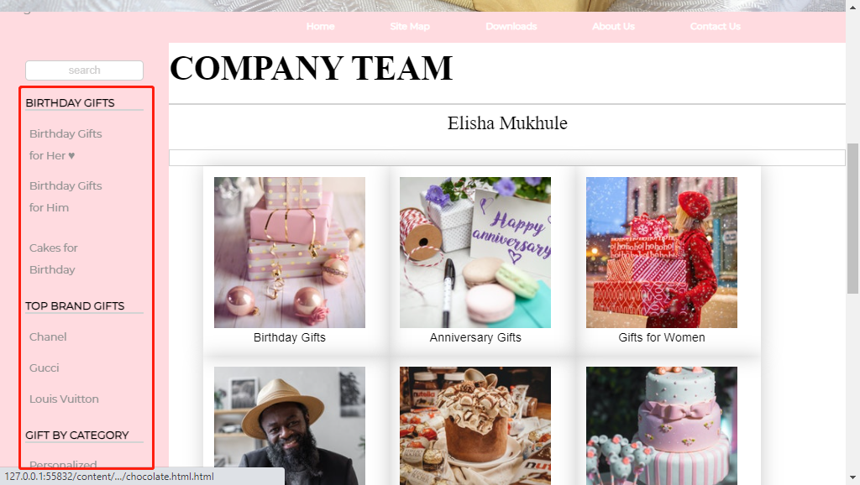

1. After identifying the product you’d like to buy, Click on the ‘Buy now’ button.

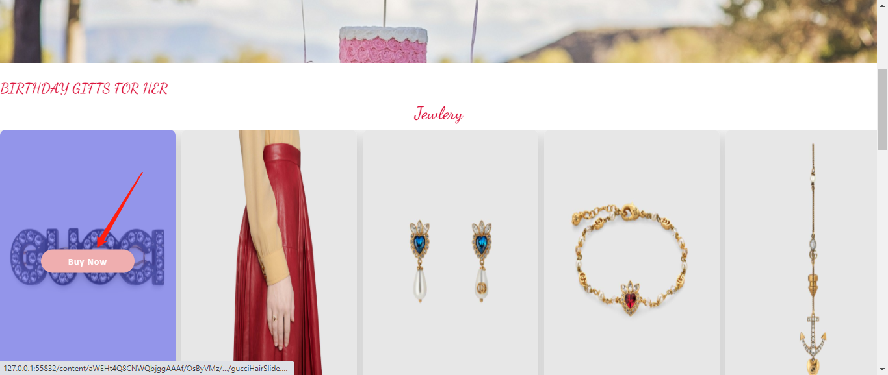

1. After clicking on the buy button, you will be directed on the product page where you check the product specification then click Add to Cart for order confirmation to take you to the Checkout Section.

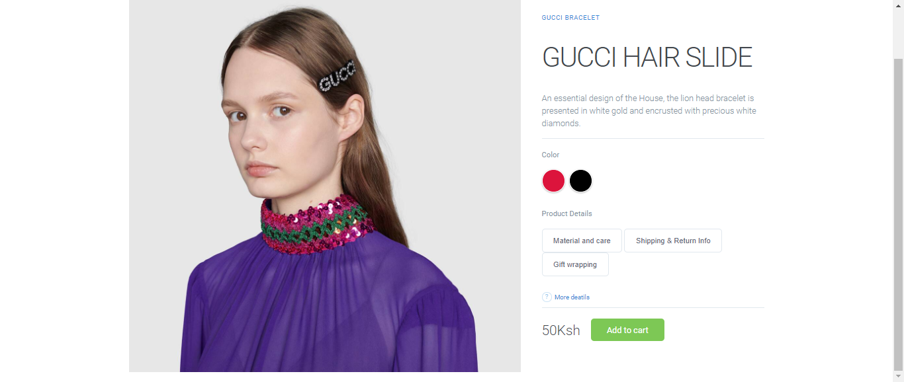

Below is the Checkout form

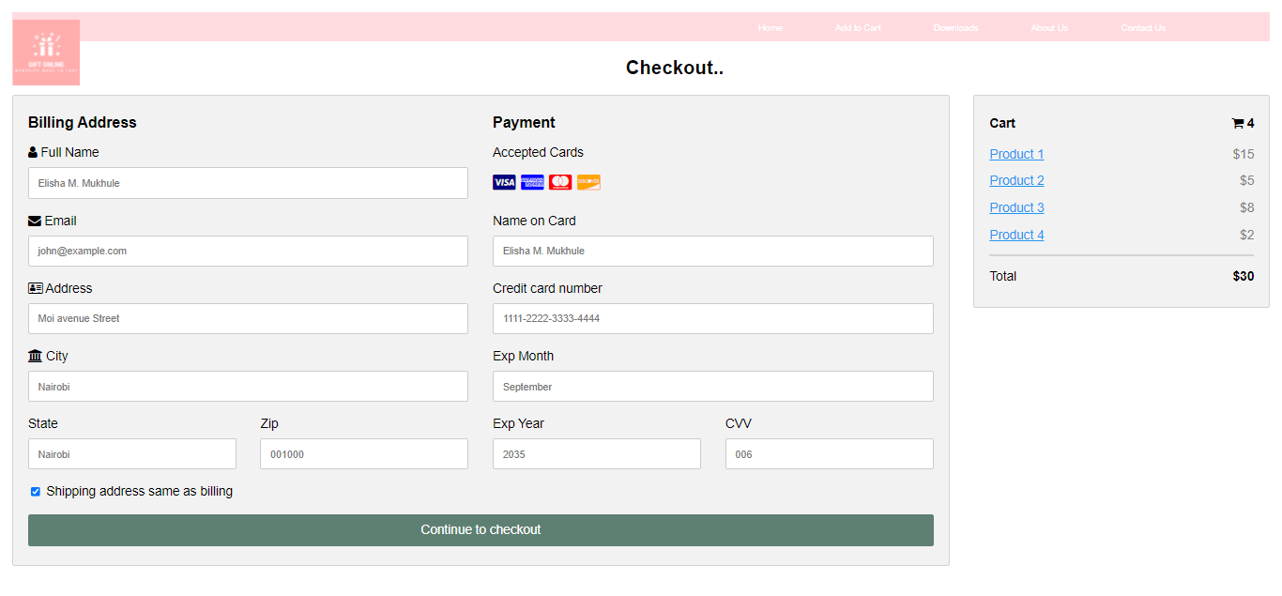

Click downloads on the navigation bar .This will take you to the download page where you will be able to download all the files about the Gift Online website



The download page below with relevant documents

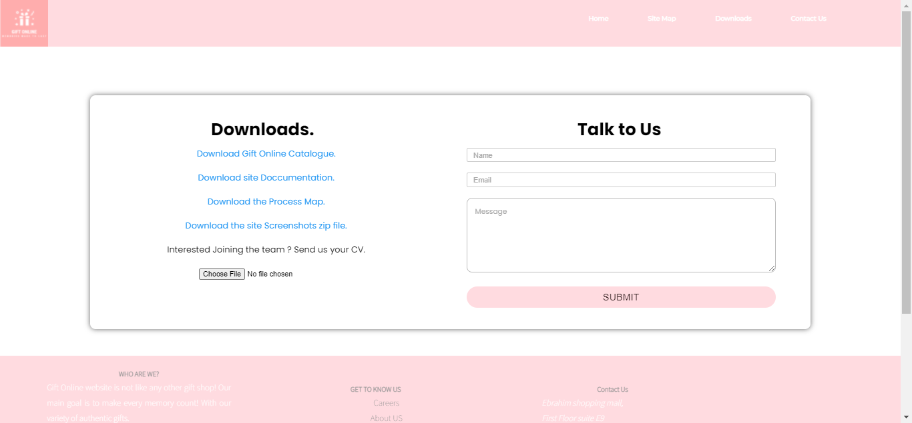

While on the navigation bar, click on the contact us . This will take you to contact us page where you will be able to ask us any questions on anything regarding our website and services aswell as our location.



The contact form is shown below



You can check some of the products sold on the homepage



## DEVELOPERS GUIDE

*THE CSS CODE BELOW IS USED ON THE HOMEPAGE*

*{

box-sizing: border-box;

margin: 0;

}

body{

font-family: 'Poppins', sans-serif;

/* height: 100vh;*/

/* width: 100%;*/

/* display: grid;*/

}

/*header*/

header {

font-family: 'Montserrat', sans-serif;

color: rgba(146,146,146,1.00);

font-size: 16px;

font-style: normal;

font-weight: 400;

background-color: #ffdbe0;

/* position: sticky;*/

}

/*FIXED TOP NAV BAR*/

div .sticky{

position: fixed;

top: 0;

width: 100%;

}

.sticky + .content{

padding-top: 60px;

}

/* END FIXED TOP NAV BAR*/

/* Logo placeholder*/

.logo img{

width: 90px;

float: left;

padding-left:5%;

padding-top:0%;

padding-left: 0%;

filter:opacity(1);

height: auto;

}

/* div for Links in header */

#headerLinks {

float: auto;

width: calc( 100% - 139px );

text-align: right;

padding-top: 10px;

padding-bottom: 10px;

background-color: #ffdbe0;

font-size: 30px;

font-weight: 700;;

}

/* Links in header */

#headerLinks a {

text-decoration: none;

color: #2B34D0;

padding-left: 66px;

font-size: 12px;

}

#headerLinks a:hover{

color: blueviolet;

transform-style: preserve-3d;

}

/* Offer text banner*/

#offer {

font-family:bitter;

clear: both;

background-color: transparent;

color:#ffffff;

padding-left: 115px;

padding-top: 57px;

padding-bottom: 57px;

}

#offer p, h2{

color: black;

flex: left;

font-size: 45px

}

.banner{

background-image:

url("../../imgs/coffee-beans-5928035_1280.jpg");

background-position:center;

background-size: cover;

background-repeat: no-repeat;

}

/* Main content of the site */

#content {

clear: both;

overflow: auto;

padding-top: 29px;

}

/* Sidebar */

#content .sidebar {

font-family: 'Montserrat', sans-serif;

color: rgba(146,146,146,1.00);

float: left;

width: 20%;

padding-left: 3%;

padding-right: 3%;

text-align: center;

background-color:#ffdbe0;

padding-top: 36px;

height: 784px;

/* position: sticky;*/

}

/* main content of the site */

#content .mainContent {

float: left;

width: 70%;

text-align: center;

padding-left: 4%;

position: sticky;

}

/*menubar's properties for menus in sidebar */

#content .sidebar #menubar {

text-align: left;

color: rgba(146,146,146,1.00);

position: relative;

left: 0%;

/* position: sticky;*/

}

/* Search field in sidebar */

#content .sidebar #search {

width: 100%;

border-radius:5px;

height: 25px;

text-align: center;

color: rgba(208,207,207,1.00);

font-size: 14px;

/* position: relative;*/

margin-bottom: 21px;

}

/* Whole page content */

#mainWrapper {

width: 100%;

padding-left: 0;

}

/*menu elements */

.menu ul li {

list-style-type: none;

font-size: x-large;

position: relative;

left: -35px;

padding-top: 12px;

}

/* Product rows for catalog */

#content .mainContent .productRow {

overflow: auto;

color: rgba(146,146,146,1.00);

}

/* Each product Information in the catalog */

.mainContent .productRow .productInfo {

float: right;

padding-left: 2%;

padding-right: 2%;

width: 25%;

}

/* Prices of a products in catalog */

.productRow .productInfo .price {

font-family: 'Montserrat', sans-serif;

color: rgba(146,146,146,1.00);

font-size: 20px;

position:relative;

top: -20px;

}

/* Content holder for products in catalog*/

.productRow .productInfo .productContent {

position: relative;

top: -37px;

font-size: 14px;

font-family: source-sans-pro, sans-serif;

font-style: normal;

font-weight: 200;

color:#211B1B;

white-space: pre-wrap;

}

/* Buy button for products in catalog */

.productRow .productInfo .buyButton {

position: relative;

top: -48px;

width: 84%;

background-color: #ffdbe0;

height: 35px;

color: rgba(255,255,255,1.00);

border-style: none;

font-size: 14px;

text-transform: uppercase;

margin-top: 8px;

}

/* footer */

#mainWrapper footer {

clear: both;

overflow: auto;

background-color:#ffdbe0;

font-family: source-sans-pro, sans-serif;

font-style: normal;

font-weight: 200;

line-height: 1.8;

padding-top: 22px;

padding-left: 22px;

text-align: center;

padding-bottom: 22px;

padding-right: 22px;

bottom: 0;

left: 0;

}

/*Each footer content */

#mainWrapper footer div {

width: 27%;

float: left;

padding-left: 4%;

padding-right: 2%;

color: rgba(255,255,255,1.00);

text-align: justify;

}

/* Links in footer */

footer div a {

color: rgba(146,146,146,1.00);

display: block;

text-decoration: none;

text-align: center;

}

/* Product's images in catalog */

.productInfo div img {

width: 100%;

}

/*Links in sidebar */

.sidebar #menubar .menu ul li a {

color: rgba(146,146,146,1.00);

text-decoration: none;

}

.sidebar #menubar .menu ul li a:hover {

color: rgba(107,97,97,1.00);

text-decoration: none;

}

/* Menu headings in sidebar */

#menubar .menu h2 {

font-size: 14px;

}

/*Links under menus in sidebar */

#menubar .menu ul li a {

font-size: 14px;

}

/* Menus in sidebar */

.sidebar #menubar .menu {

margin-bottom: 29px;

}

/* Container for links in footer */

footer .footerlinks {

margin-top: -15px;

}

/* Media query for tablets */

@media screen and (max-width:700px) {

/* search field in sidebar */

#content .sidebar #search {

display: none;

}

/* sidebar */

#content .sidebar {

float: none;

width: 100%;

height: auto;

overflow: auto;

padding-left: 12%;

padding-top: 0px;

}

/* horizontal separators in sidebar */

#content .sidebar hr {

display: none;

}

/*The sidebar and maincontent of page */

#content {

position: relative;

top: -22px;

width: 100%;

overflow: hidden;

}

/*menu headings in sidebar */

#menubar .menu h2 {

display: inline;

font-size: medium;

padding-right: 6%;

}

/* Unordered List of links */

#menubar .menu ul {

display: inline;

}

/*list elements */

#menubar .menu ul li {

display: inline;

font-size: medium;

padding-left: 0%;

padding-right: 3%;

}

/*The link to be hidden in tablet view */

.sidebar #menubar .menu ul .notimp {

display: none;

}

/* menus in sidebar */

.sidebar #menubar .menu {

width: 100%;

text-align: center;

position: relative;

top: 16px;

}

/*menubar in sidebar */

#content .sidebar #menubar {

position: relative;

left: -7%;

overflow: hidden;

width: 95%;

padding-top: 0px;

}

/* offer banners content */

#mainWrapper #offer p {

font-size: small;

}

/* main content region of page */

#mainWrapper #content .mainContent {

overflow: hidden;

width: 95%;

margin-top: 40px;

}

/* Prices of products in catalog view */

.productRow .productInfo .price {

font-size: 19px;

}

/* Content holders in catalog view */

.productRow .productInfo .productContent {

font-size: 16px;

}

/* Buy buttons in catalog view */

.productRow .productInfo .buyButton {

font-size: 15px;

}

/* Container for links in footer */

#mainWrapper footer .footerlinks {

float: none;

width: 100%;

position: relative;

top: 17px;

clear: both;

text-align: center;

left: 0%;

padding-bottom: 19px;

}

/* Container for each footer divisions */

#mainWrapper footer div {

width: 44%;

text-align: justify;

font-size: 15px;

}

/* Links in footer */

.footerlinks p a {

padding-top: 0px;

padding-bottom: 0px;

display: inline;

padding-right: 35px;

}

/* Footer region */

#mainWrapper footer {

padding-left: 16px;

overflow: visible;

}

/* Links in header */

header #headerLinks a {

padding-left: 0px;

padding-right: 30px;

}

/* Offer- Text banner */

#mainWrapper #offer {

padding-left: 22%;

}

/* Paragraphs in footer */

footer .footerlinks p {

display: inline;

}

}

/*media query for small screen devices */

@media screen and (max-width:480px) {

/*Container for links in header */

#mainWrapper header #headerLinks {

width: 100%;

text-align: center;

background-color: #ffdbe0;

padding-bottom: 21px;

}

/* Logo placeholder*/

#mainWrapper header #logo {

width: 100%;

text-align: center;

}

/* Links in header */

header #headerLinks a {

text-align: center;

padding-right: 15px;

padding-left: 0px;

color: #000;

}

/*Offer - Text Banner */

#mainWrapper #offer {

padding-left: 0px;

text-align: center;

}

/* Menubar in sidebar */

#content .sidebar #menubar {

position: relative;

left: -8%;

text-align: center;

}

section .mainContent .category{

padding-bottom:25px;

}

/*Menu headings in sidebar */

#menubar .menu h2 {

width: 100%;

display: block;

}

/* Each product in catalog view */

.mainContent .productRow .productInfo {

width: 100%;

display: block;

padding-left: 0px;

padding-right: 0px;

position: relative;

left: -2%;

}

#mainWrapper footer div {

width: 100%;

margin-left: -16px;

text-align: justify;

padding-bottom: 16px;

overflow: auto;

}

/* Unordered list for menu elements */

.menu ul {

position: relative;

padding-left: 24%;

}

/* Container for links in footer */

#mainWrapper footer .footerlinks {

padding-left: 8%;

}

/* Main content which excludes the sidebar */

#mainwrapper #content .mainContent {

margin-top: -81px;

text-align: center;

width: 100%;

padding-left: 0px;

}

}

.section-heading{

text-align: center;

font-family:Cambria, "Hoefler Text", "Liberation Serif", Times, "Times New Roman", "serif";

background-color:#ffffff;

line-height: 50px;

color: crimson;

}

*THE CSS CODE BELOW IS USED IN ADDITION TO THE HOMEPAGE CSS CODE ON BIRTHDAY GIFT PAGE, TOP BRAND GIFTS PAGE, GIFT BY CATEGORY, PERSONALIZED GIFTS, PERSONALIZED MUGS, PERSONALIZED CLOCKS, PERSONLAIZED CUSHIONS & PILLOWS*

/*section 2----*/

.category{

display: flex;

flex-wrap: wrap;

}

.category-card{

padding: 2%;

box-shadow: 1px 1px 25px rgba(0,0,0,0.2);

flex-grow: 1;

flex-basis:220px;

display: flex /*So that the child elements can use flexbox stuff tool aswell*/

}

.category-img img{

max-width: 100%;

}

/*RESPONSIVE FLEXBOXING.*/

@media(max-width:920px){

.category-card{

flex: 1 25%;

}

}

/*End of Section 2 -----*/

figcaption a{

text-decoration: none;

}

figcaption a:hover{

color: #BF7173;

}

.heading{

color: crimson;

font-weight: 600;

font-family: Consolas, "Andale Mono", "Lucida Console", "Lucida Sans Typewriter", Monaco, "Courier New", Consolas, 'Andale Mono', 'Lucida Console', 'Lucida Sans Typewriter', Monaco, 'Courier New', 'monospace';

float: left;

**}**

*THE CSS CODE BELOW IS USED IN THE SLIDER FOUND ON BIRRTHDAY GIFTS FOR HIM AND HER PAGES, GUCCI PAGE. CHANEL PAGE, FLOWERS PAGE.*

*/*PRODUCT SLIDER*/*

*.product-slider-1,.product-slider-2{*

*background-color:transparent;*

*position: relative;*

*box-sizing: border-box;*

*margin:inherit;*

*}*

*.box{*

*width: 300px;*

*box-shadow: 2px 2px 30px rgba(0,0,0,0.2);*

*border-radius: 10px;*

*overflow: hidden;*

*height: 100%;*

*}*

*.slide-img{*

*height:450px;*

*position: relative;*

*}*

*.slide-img img{*

*width:100%;*

*height:100%;*

*object-fit:fil;*

*box-sizing: border-box;*

*display: inherit;*

*}*

*.detail-box{*

*width: 100%;*

*display: flex;*

*justify-content: space-between;*

*align-items: center;*

*padding: 10px 20px;*

*box-sizing: border-box;*

*font-family: calibri;*

*}*

*.type{*

*display: flex;*

*flex-direction: column;*

*}*

*.type a {*

*color: #222222;*

*margin: 5px 0px;*

*font-weight: 700;*

*letter-spacing: 0.5px;*

*padding-right: 8px;*

*text-decoration: none;*

*}*

*.type span{*

*color: rgba(26,26,26,0.5);*

*}*

*.price{*

*color: #333333;*

*font-weight: 600;*

*font-size:1.1rem;*

*font-family: poppins;*

*letter-spacing: 0.5px;*

*}*

*a:hover{*

*color: rgba(92,95,236,0.6);*

*}*

*a{*

*text-decoration: none;*

*}*

*.overlay{*

*position: absolute;*

*left: 50%;*

*top:50%;*

*transform: translate(-50%,-50%);*

*width: 100%;*

*height: 100%;*

*background-color: rgba(92,95,236,0.6);*

*display: flex;*

*justify-content: center;*

*align-items: center;*

*}*

*.buy-btn{*

*width: 160px;*

*height: 40px;*

*display: flex;*

*justify-content: center;*

*background-color: #FFFFFF;*

*color: #252525;*

*align-items: center;*

*font-weight: 700;*

*letter-spacing: 1px;*

*font-family: calibri;*

*border-radius: 20px;*

*box-shadow: 2px 2px 30px rgba(0,0,0,0.2);*

*}*

*.buy-btn:hover{*

*color: #ffffff;*

*background-color: #EFAEAF;*

*transition: all ease 0.3s;*

*}*

*.overlay{*

*visibility: hidden;*

*}*

*.slide-img:hover .overlay{*

*visibility: visible;*

*animation: fade 0.5s;*

*}*

*@keyframes fade{*

*0%{*

*opacity: 0;*

*}*

*100%{*

*opacity: 1;*

*}*

*}*

# CHAPTER 4: CONCLUSION AND RECOMMENDATION

**CONCLUSION**

In conclusion the website created can be further developed and modify to use complex equations like the quadratic equations and many others. The website also can be executed on other leading browsers like Safari, Firefox, and Chrome etc.

**RECOMMENDATION**

We recommend further research for modification of this website in the future so that we can come up with more advanced website which can be used in almost every other browsers